The Visual Arts Archive

* * *

Section 1: Acrylic Painting (Part One)

It has been my personal experience that as I allow the painting to speak
I become lost, it is delicious and at the same time frightening.
The best ones, to me, have a life of their own.” – Luther E. Vann

***
Towards the end of February, my visit with my son was almost over, but I was eager to continue learning by painting. Using a small easel, paints, brushes, and canvases purchased the day we came back from Muskoka, I tried my hand at it a second time before leaving. This time I employed memory and imagination to survey Nature, and spent time considering a wide range of possible subjects, ultimately settling on the idea of a solitary cherry blossom tree on a hill. I studied images of cherry blossom trees on the Internet, noted some commonalities that captured the essence of a cherry blossom tree, and the essence of the one I held in my imagination.
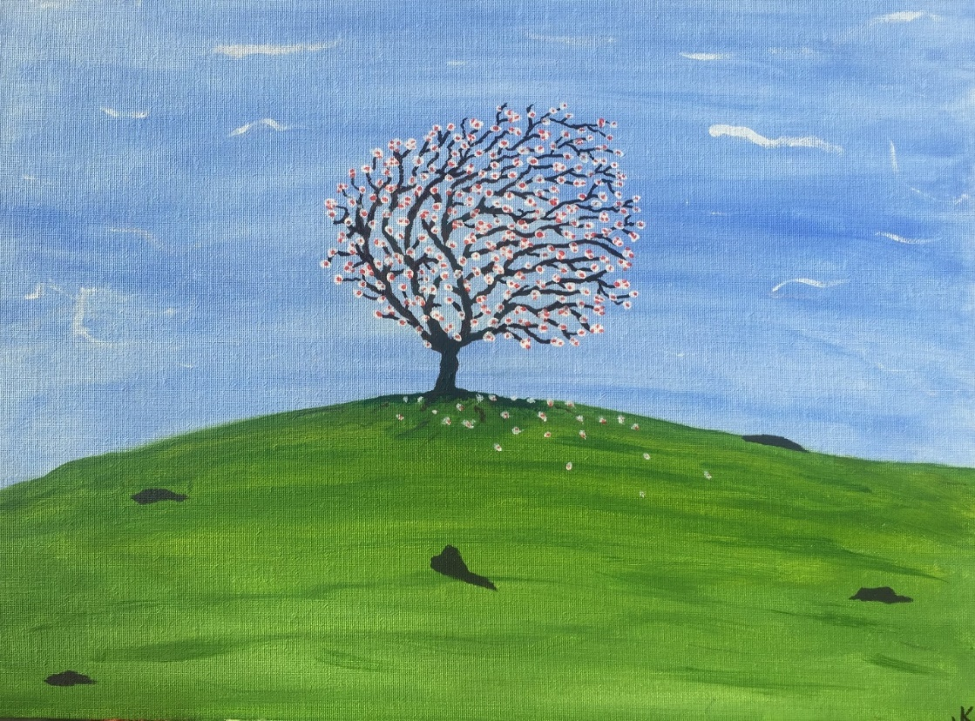

I put away the computer, and “Imagined Cherry Blossom” was completed in about ninety minutes in one sitting. The sedating effect I felt in Muskoka was present once again, especially in creating the network of branches that are influenced by the prevailing wind, in making the flowers on the tree blossom one by one, and in randomly distributing the fallen blossoms scattered beneath the tree, also influenced by the wind.
As with “First Foray”, I was fairly pleased with my still fledgling efforts to achieve an acceptable sky and clouds; and the round hill, the various rocks sticking out of the ground, and the depth of the green in the grass according to distance from the vantage point, provided opportunities to give the piece some depth.
Admittedly, it is an unremarkable piece, but it helped me confirm and crystalize a few things that appeared on my maiden voyage; and it helped me begin to feel comfortable in front of an easel with a brush, surrounded by all the necessary accoutrement. Most importantly, it showed me that the nascent abilities I found in creating with acrylic paint that first emerged in Muskoka, was no fluke; and it kept my painter’s spirit alive and looking forward. It only remained to find out how far I could take it, and how significant the impact of the therapeutic effect of painting would be on my health and well-being.
“Imagined Cherry Blossom” now hangs in my personal bathroom at home.

***

I left Toronto with the sneaking suspicion that I had turned the corner on the rest of my life. I greeted my wife, Tina, in Toronto airport, and together we headed south for our annual private Valentine vacation in February. This year was our second visit to an oceanside boutique hotel in Ixtapa, Mexico.
I had packed my little set of art supplies because I knew there would be lots of things in Mexico I could try to paint to keep my newfound creative juices flowing. We had a reservation for the same fine room with balcony and plunge pool as we had previously, and as soon as we saw the view from the room again I knew I would try painting that view over the course of the week.
During the next day, I watched the sunlight and its effects, and when it became what I thought was best (the two hours on either side of noon), I took a few pictures to which I could refer if I wanted to study the scene or paint in the morning or evening. I settled on one shot I thought was best…

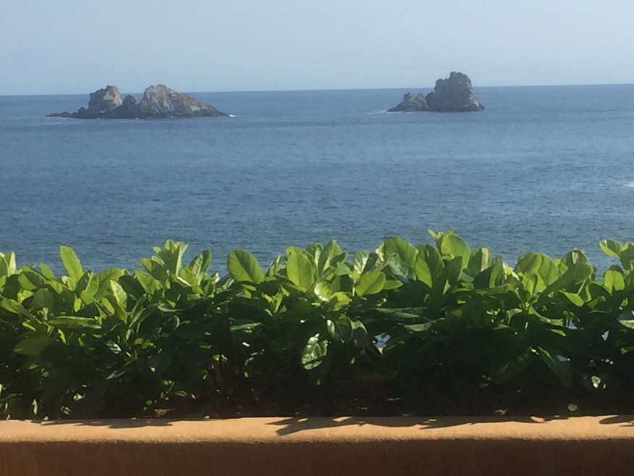

As is so often the case, no picture comes close to doing justice to any scene observed in person; as it was with the view looking straight out from our balcony in Ixtapa. So many of the elements involved were in constant flux – the deep green-blue ocean that changes in shade according to the depth of the water, the time of day, and the distance from the vantage point; the definition in the rock; waves periodically crashing around the rocks; birds happening by – so the painting would have to be based on an amalgam of different perspectives, varying degrees of haze, and varying levels of direct sunlight (and therefore shadows).
It turned out to be a lot of good, relaxing fun for both Tina and me, as we set aside a few hours each day for me to paint while she tanned, plunged, or read her book. It was fun for the cleaning ladies too because each day they could see the progress since the day before, and their appreciation of it (two thumbs up by the end of the week) helped my fragile confidence as a painter. Tina’s growing amazement with what I was doing was a daily boost to my work as well.
It was finished late in the afternoon of the day before we left, and Tina and the ladies gave “Ixtapa Vision” their wholehearted approval…

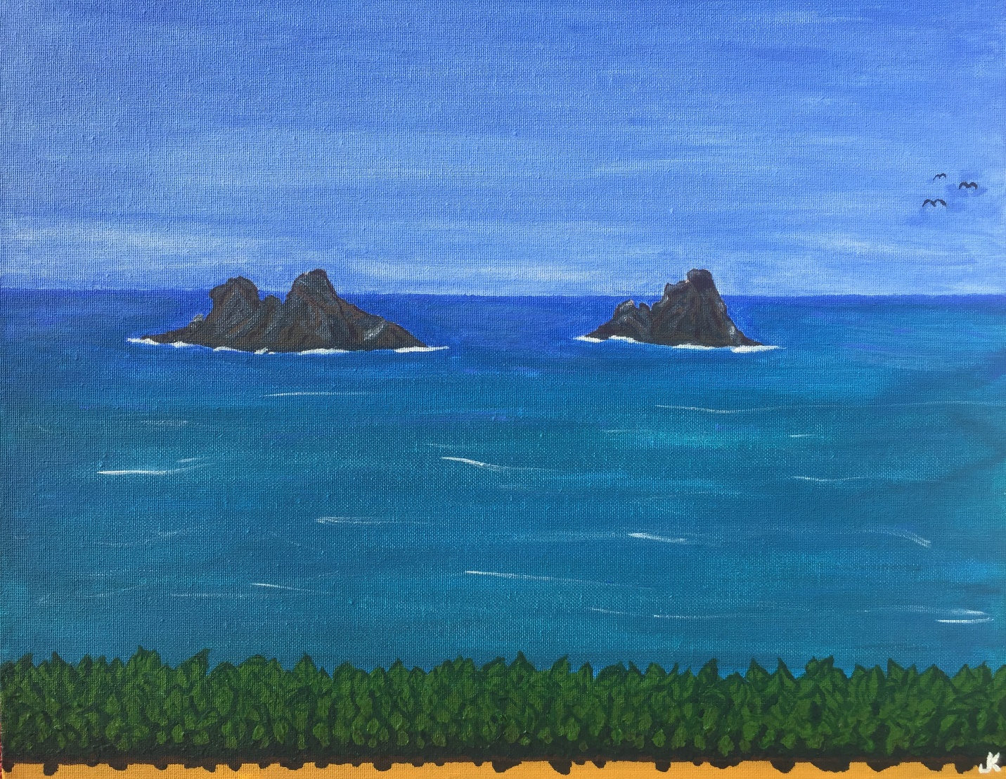

In many important ways, this my second painting was an advance on the first one. But I can see, at this very early stage of my development as a painter, plenty of evidence of work that needed to be done, and in some cases still does. But the overall effect of the piece is, I believe, a good deal better, and it is certainly more consistent. This was also my first time working with a live model, as it were, using and stretching many of my artistic muscles in this genre for the first time. For instance, while painting, I could see that the closer the ocean came to the horizon, the closer it came to looking like the blue in the sky near the horizon, and I was pleased that I had achieved this to some extent.
However, despite the calming effect the activity of painting had on me for almost all the time spent doing it there on the balcony, I remember feeling panicked when I was trying to get the near ocean’s special shade of blue-green right – the growing fear of a major failure, frantically fixing it over and over, until finally it started to come around – and then when it got a little closer I thought it best to quit while I was ahead, heart pounding, feeling like I had just dodged a bullet. Though I still cringe to see shadows in the soil under the leaves in the painting looking more like melted chocolate dripping out over the edge of the planter, the creation of “Ixtapa Vision” certainly made our vacation even more memorable than it would have been, and I was encouraged enough by the experience and results to look forward to getting home and tackling the next piece.
Like “Imagined Cherry Blossom”, “Ixtapa Vision” hangs in my home to remind me of my beginnings in acrylic painting; to keep me honest, so to speak.

***

Back in Newfoundland, I was eager to get to Branch as soon as I could to look at the view I had painted from memory. When I arrived, I looked out at it but, in a very real way, I was seeing it for the first time. It was then I realized how much painting had transformed the way I looked at the world, and the way I would look at it for the rest of my life. Now, home with three decent paintings under my belt, I was looking at all things much more closely. Standing on the deck of the beach house taking in the scene, I was seeing lines, light and shadow, colour and shades of colour. I’m sure I saw them before but didn’t realize it.
I am a person who is ever interested in life and all that it holds, so I am the kind that can’t wait to see what happens next. But, as a painter, life was becoming even more interesting for me, and I was paying a lot more attention to the details. Suddenly, everything, everyone, and every scene was potential subject matter for painting, so everything was relevant.
Behind me, at my shoulder, Tina said she would like me to paint that scene for us again in Branch, as opposed to on the mainland from memory, with letters spelling “Our Beach House Is My Happy Place”. I loved the idea and set to work. First, I brought up our favourite picture of the view, one I like so much I use it for the banner of this website and my Facebook page. I needed the picture shown here so that I would be able to refer to both the scene changing in front of me in real time, and a fixed, ideal picture of the scene…

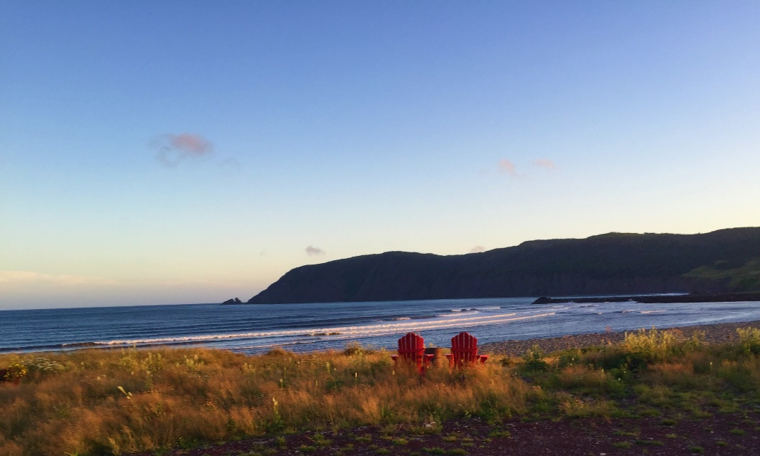

Working on painting and creating in Branch for the first time was a holy experience for me. With my studio looking out over the incredible scene I was painting, I became genuinely overwhelmed with joy. It was at once exciting and becalming: exciting for being here with the task of painting this awesome view before me; becalmed by the act of painting, and the comforting thought that this was only the beginning. Here is a pictorial account of some of my progress through the process of creating “My Happy Place” …

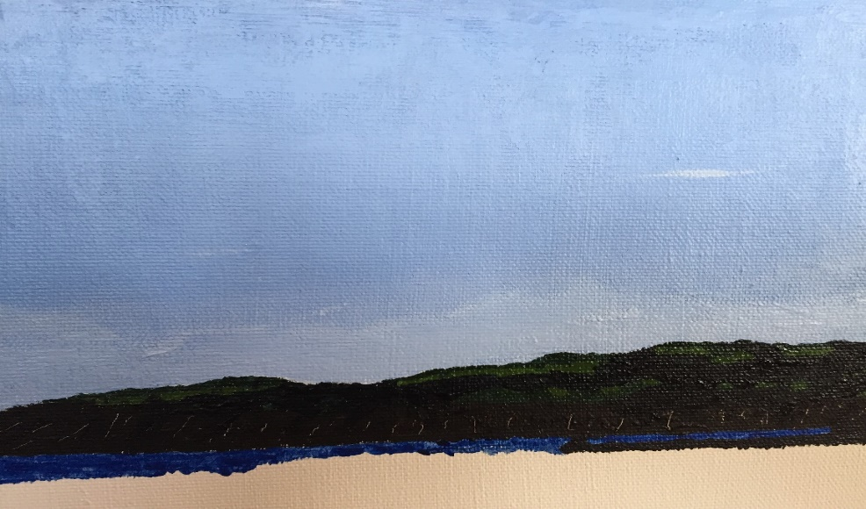

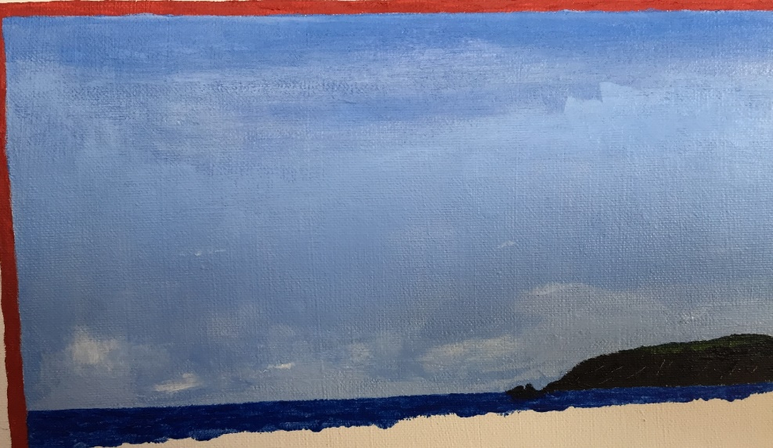

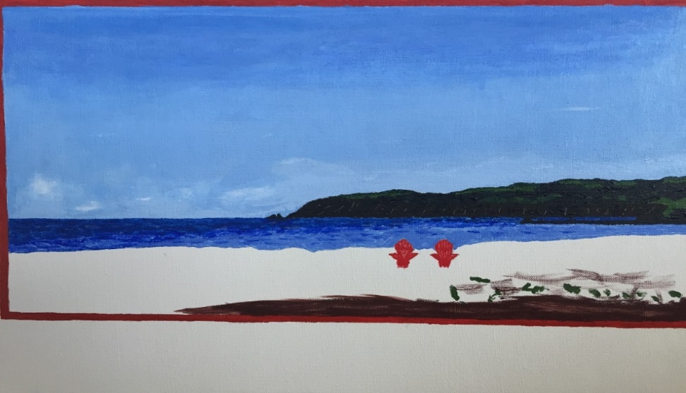

I look back on this as a lot of work that was also a whole lot of fun, more fun than I had enjoyed in many years, and a different kind of fun than I have ever had! I particularly loved working on the grass in the foreground, and the beach rocks off to the right.

Looking at the details now, the vibrant colour, the balance and overall consistency of the piece, with the thoroughly positive reactions of everyone who has seen it, “My Happy Place” demonstrated to me that I had achieved a whole new level of skill and efficiency, which was hugely encouraging, to say the least; and I still gaze with pride on the realism in the clouds, the difference in water depth, the rows of waves rolling in, and the beach rocks…

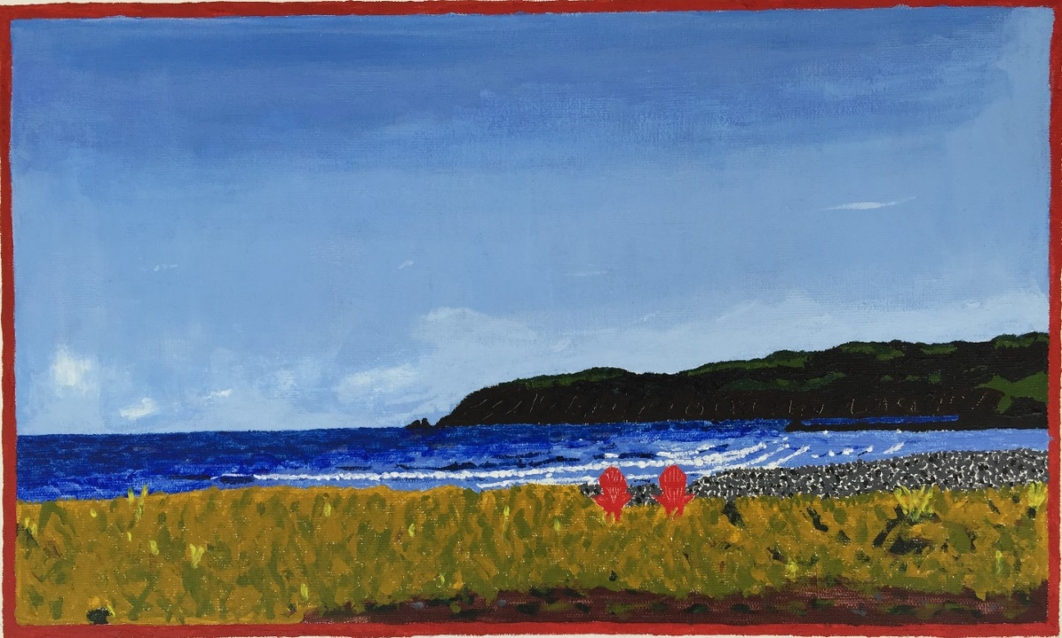

To imbed it in a craft work, as requested by my wife, I still had a bit of work to do. The painting was rendered in the middle of a canvas, to make room for the lettering and framing (in beach house tones, of course), and “My Beach House is My Happy Place”, which includes “My Happy Place”.

Like the rest of my early work, it now hangs in our home…

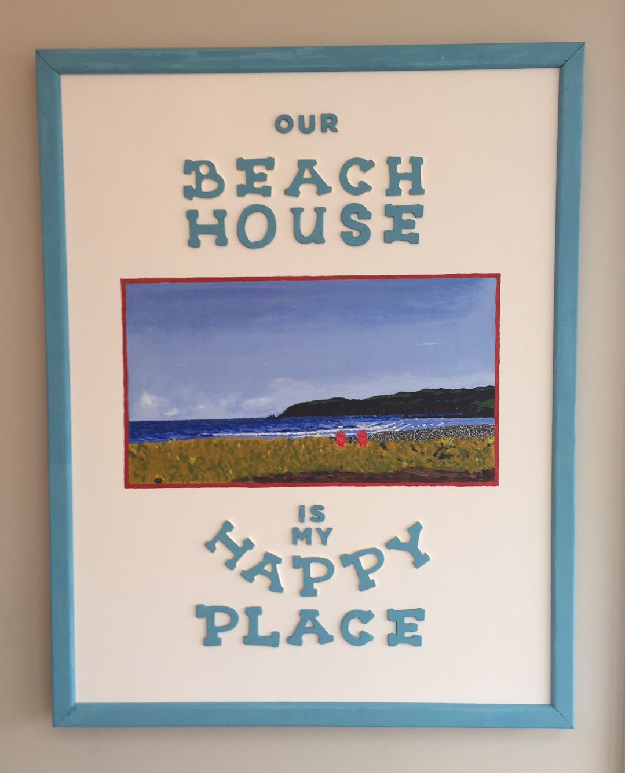

Painting/crafting the piece took more than a week to finish, and ever since we hung it my wife has been saying: “You need to paint a bigger one of that scene for us!”

***

Inspired as I was by my first five paintings, having ventured somewhat successfully into several unfamiliar artistic/creative territories along the way, I decided to challenge myself further with my first try at painting the human form.

My granddaughter, who was three years old at the time, just loves to dance. She is quite good at it and stunningly beautiful, so it is not unusual that I selected an image of Aliyah dancing as the subject matter for this painting. But I wanted viewers to see the motion in her dancing, and I possessed nowhere near the skill and experience to even attempt it.

A week or two earlier, Aliyah and her brother Adam had a photo shoot at a professional photographer’s studio, and the family was given a dozen or more sheets of tiny proofs to take home and decide which ones we wanted included in the package. I decided to select three proofs of Aliyah dancing which, when placed beside each other in a row from left to right, almost provided the illusion of motion by depicting three stages of one spinning dance move. I chose the following pictures as models for the painting, after having no choice but to take three grainy, extreme closeups of the tiny proofs:

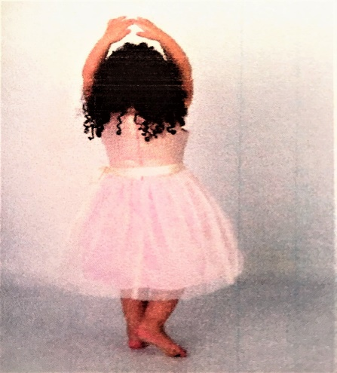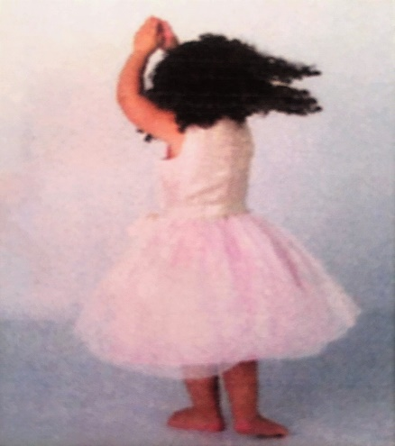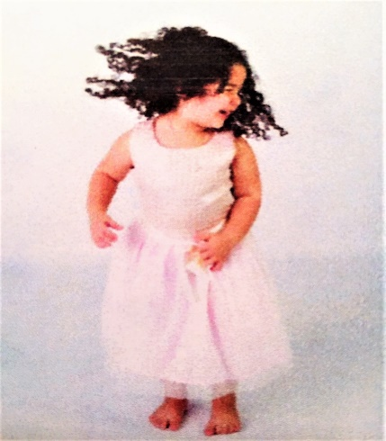

The exquisite dress, its bodice and layered skirt both encrusted with costume gems and sparkles, and the varying shades of pink, was a joy to paint all by itself, as were her tight black tresses in action. So, there were plenty of opportunities to give the piece depth and realism with thick, stippled, unconventionally applied paint, especially with her curls.

The biggest challenge of all was skin colour, and the varying shades of skin colour – one of the toughest aspects of painting portraits of any kind. Even so, feeling like I had dodged another bullet, I was pleased with how it turned out, especially given it was my first attempt.

The time spent painting “Princess Dancing” was like enjoying the precious company of its model. Such a wonderful way to pass time…

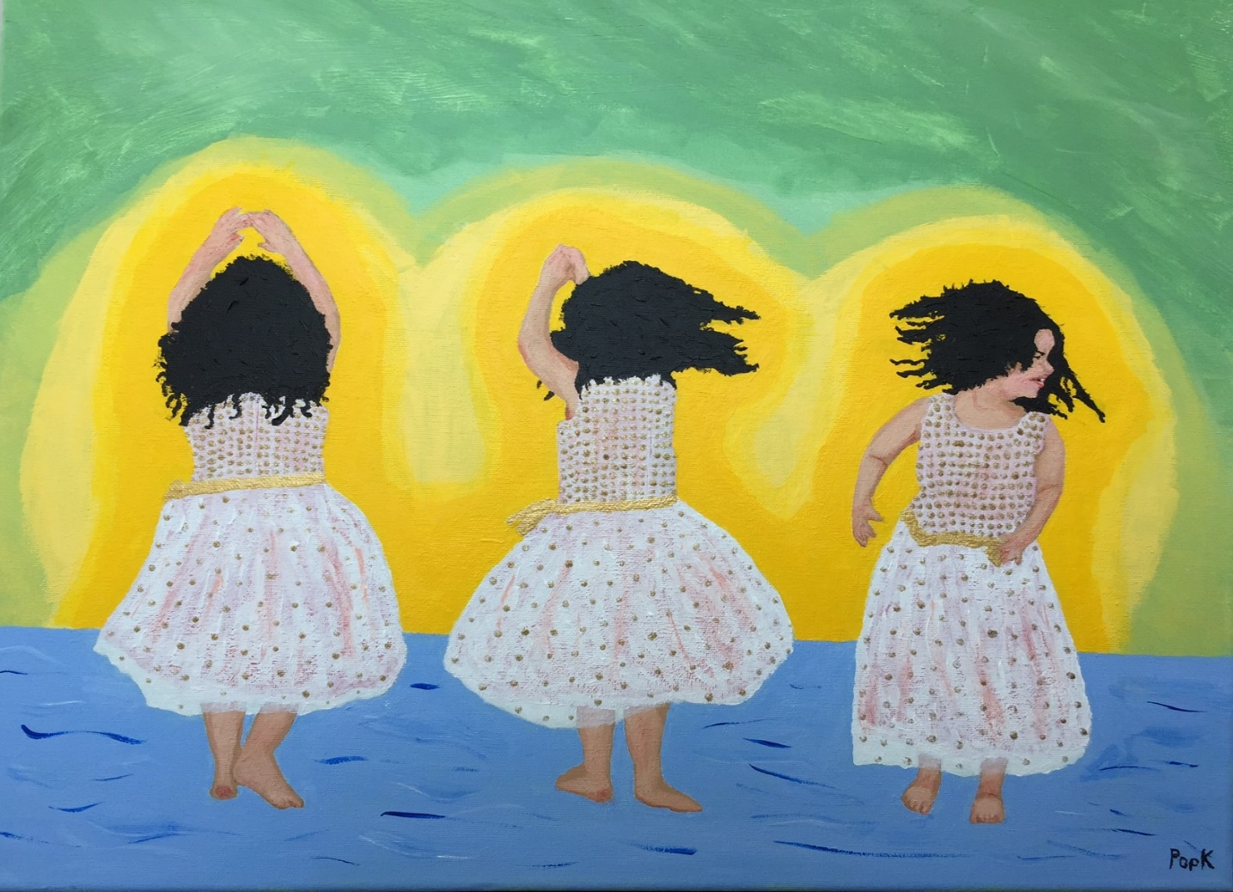

And here are two insets, highlighting the colour and texture of the dress that were taken during the work. Again, the pictures cannot do justice…

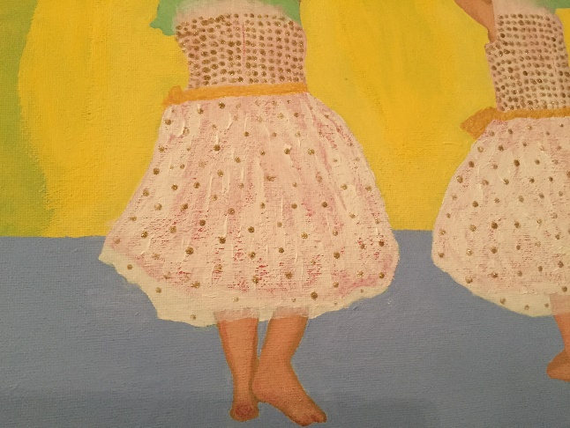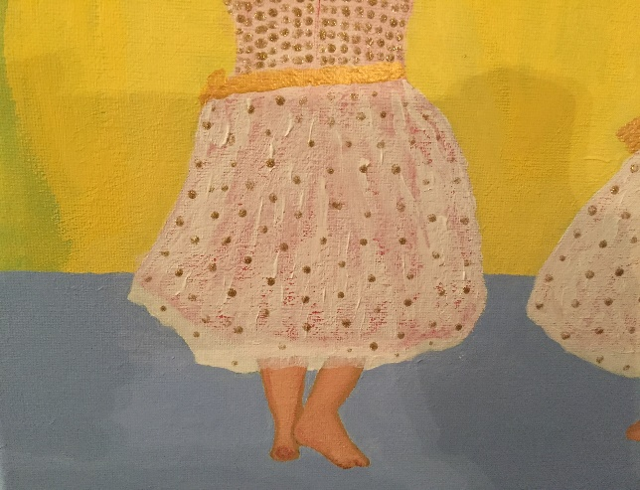

I created “Princess Dancing” during a sunny Branch week in May, alone in our beach house – the perfect circumstances under which to paint. To prevent cramps and back problems, I spent the odd hour converting my shed into a studio, and the rest of the time in the open-concept kitchen/dining/sunroom of the beach house, painting with the brilliant sunshine streaming in.

The best takeaway was that, by week’s end, I realized I hadn’t been alone at all – I was spending the week with Aliyah, studying in detail the colours and textures in her hair, skin and clothes. I’ll never forget the feeling of joy at the hair-raising moment I saw her start coming back to me out of the painting, as I knew that I had captured her, at least to some significant extent.

Though I avoided the subject’s face and eyes, believing discretion to be the better part in this respect, I managed to get through creating my first painting of the human form with a result I can live with. It seems Aliyah and her family can live with it too, because that’s what they’re doing – “Princess Dancing” now hangs in the dining room of their home in Miramichi, New Brunswick.

***

At this point, I needed to keep painting, but I was somewhat drained by the attention and energy expended on my last two pieces. I needed to have some pure, palette-cleansing fun with it and try to take myself just a little less seriously as a painter for a while.

First, it was “Fox” for my grandson Adam’s room…

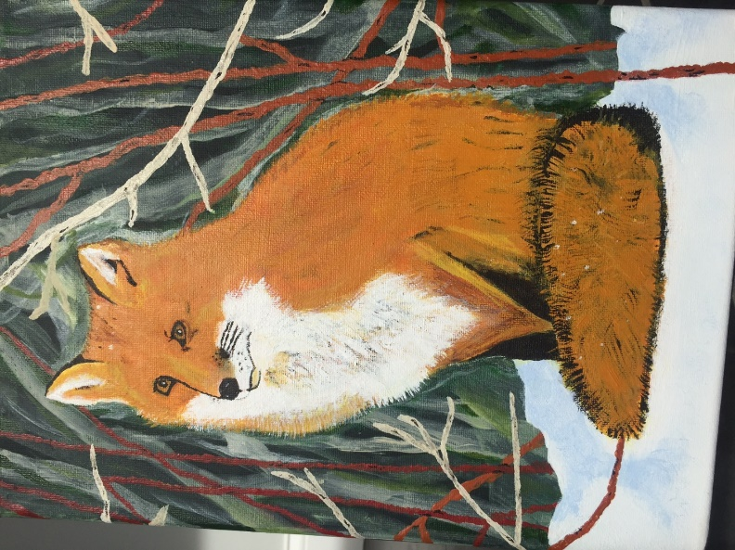

Then, we needed a painting of “Princess Poppy Troll” for Aliyah’s room…

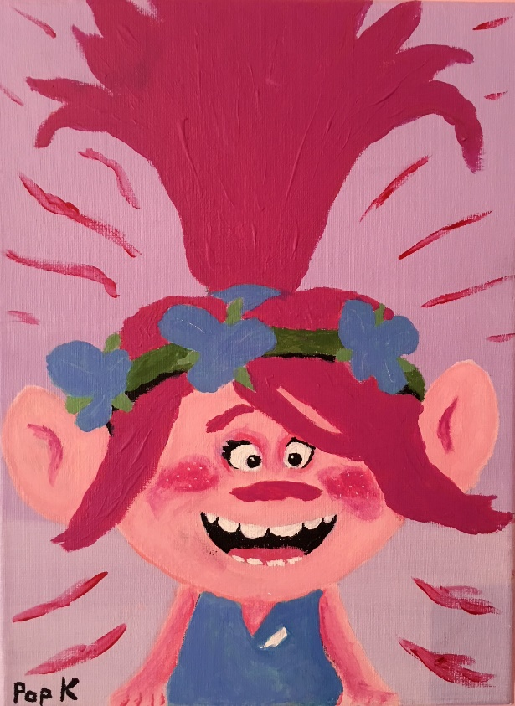

And then along came Schatz (the German word for ‘treasure’), our new King Charles Cavalier puppy, so my first painting of him, “Puppy Schatz”, came very soon thereafter…

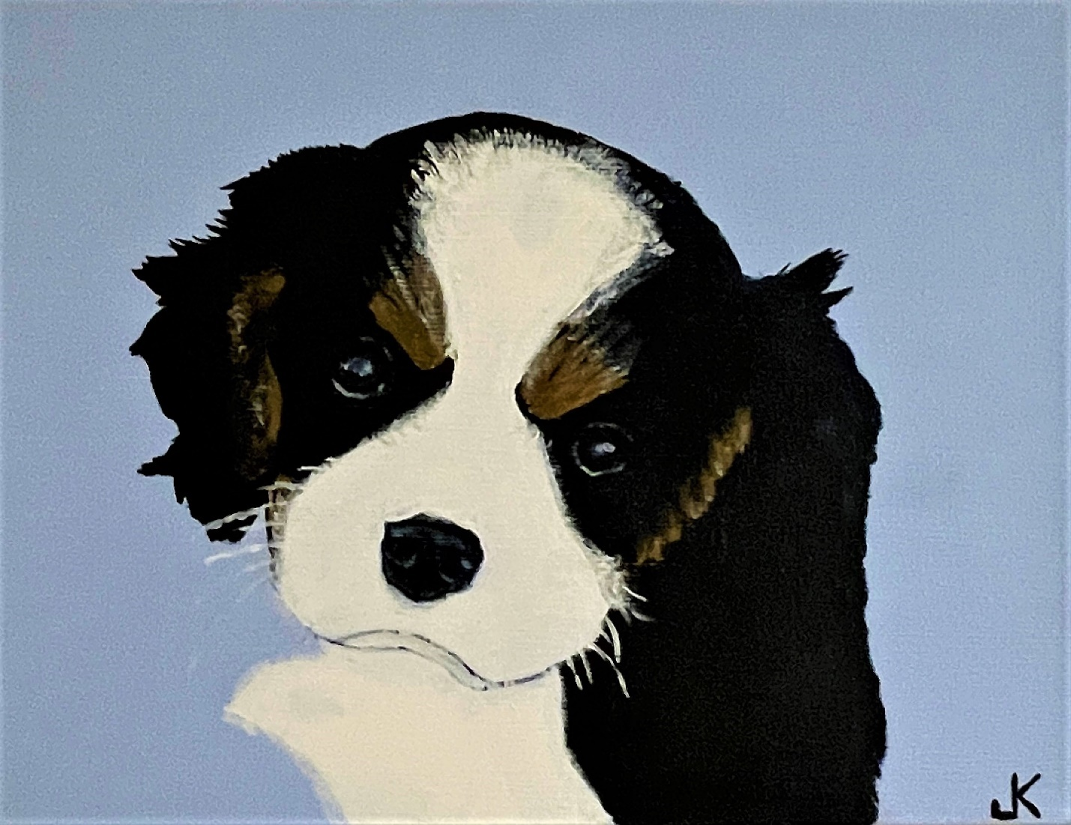

…he is so intense!

***

The first time I met Tina’s youngest daughter, Maria (affectionately known in the family as “M”), she was only nine years old; and the first time the three of us spent time together was for a weekend in Branch. I was struck by her pure, girl-next-door beauty and placid temperament, but mostly by how well she treated me, right from the start, which I appreciated more than I can say. We took a lot of pictures that weekend, and one shot always makes me smile because it reminds me of how nice she was to me from the outset, and she still is. It was one of Maria, standing on the river flats in the fog, preparing to feed a couple of horses some grass.

Today, Maria lives in Nova Scotia working as an engineer. I thought it would be nice for her to have a painting of mine she would like to hang in her home, one depicting something we could both relate to, and that picture of her on the flats was special…

I started by getting the proportions right, sketching/outlining the main elements in the composition…

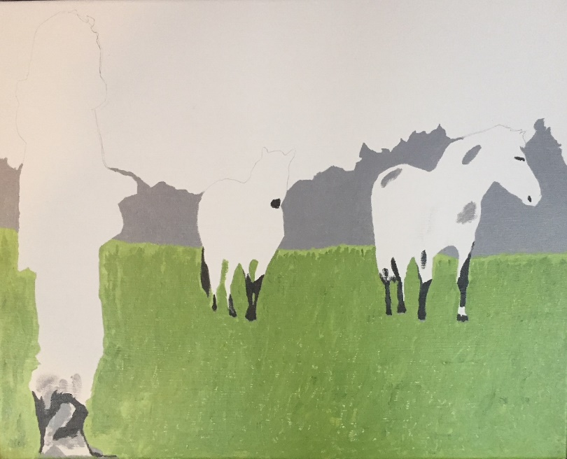

Next, I needed to bring in the fog before I could get down to the detail on the figures in the foreground…

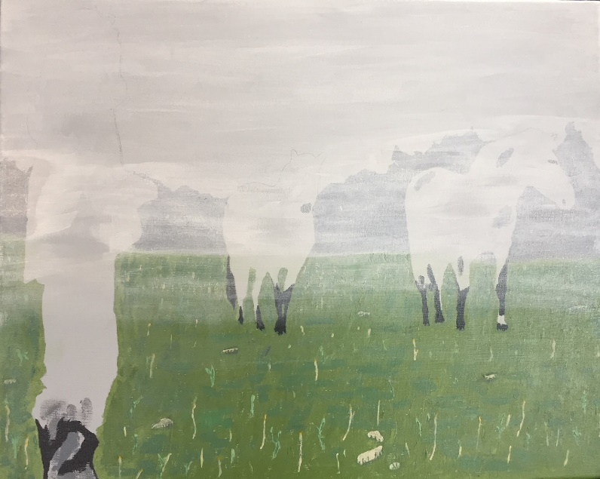

Now I could start getting to work on the colours…

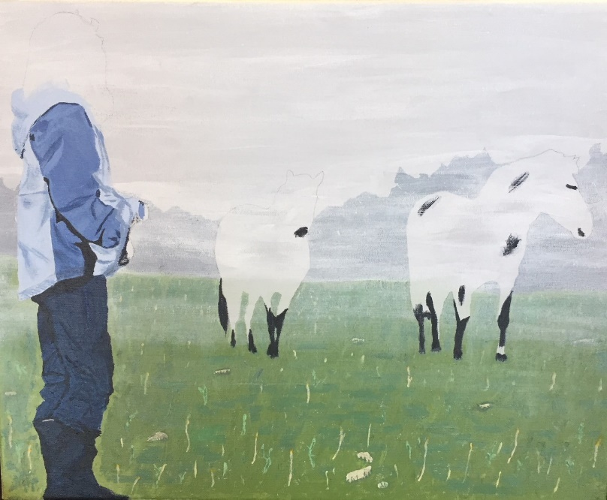

… and fill out the scene…
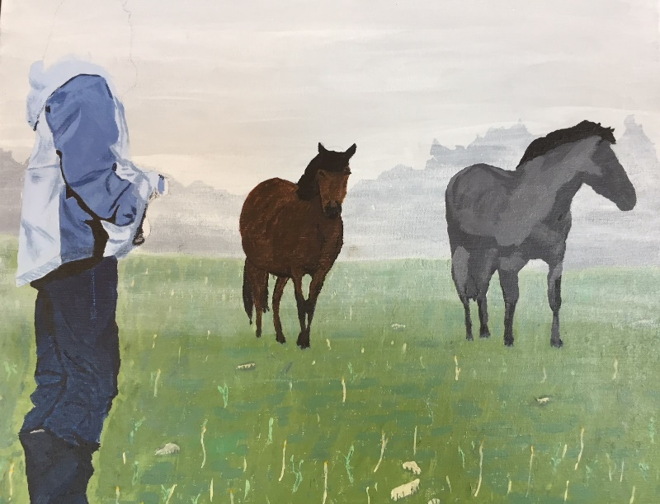

Finally, the moment came when I saw Maria looking back at me, just as she was on that day so long ago, and “M9 on the Flats” was finished…

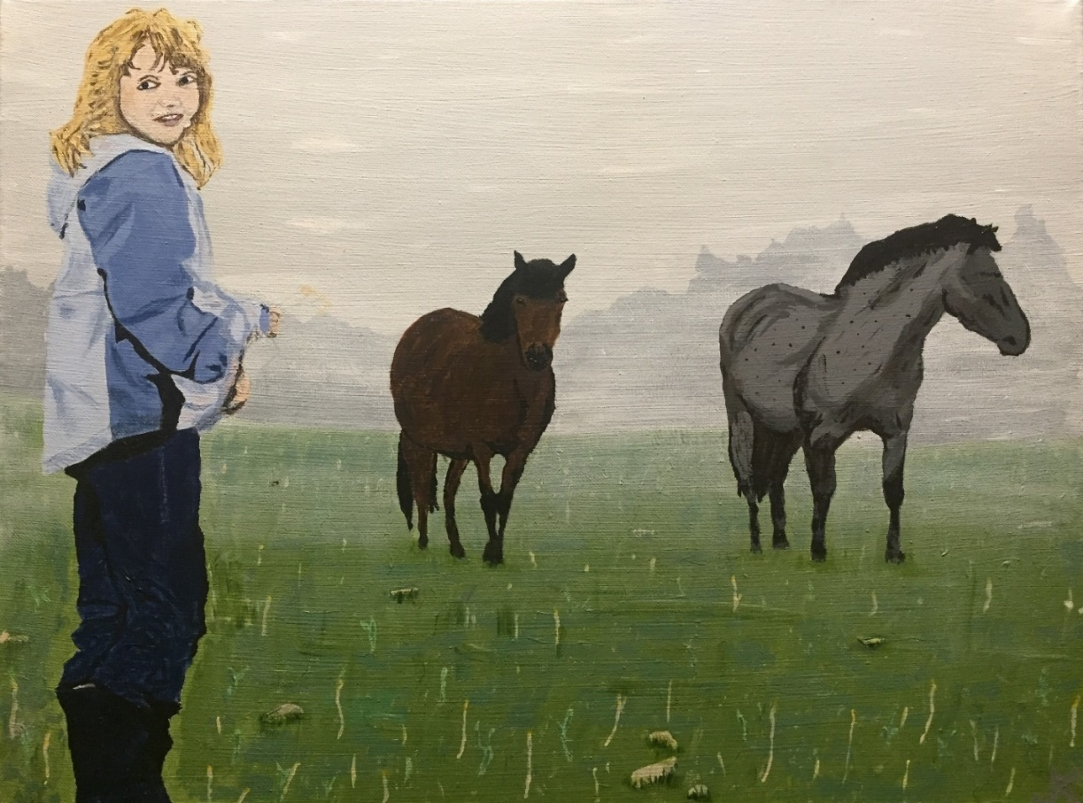

For a long time, I thought I was seeing her in the painting because I wanted to. But then an elderly gentleman who worked in Branch many years ago, when Tina and her sister Rose were just children, came to visit. He took one look at the painting and said: “Oh, my God! That’s what Rose looked like when she was around ten years old! Just like that!” I knew then that I had come close.

Maria came home for Christmas that year. On Christmas morning she unwrapped the painting, and I could see that she really meant it when she said she loved it. She took it back with her, and now it lovingly hangs in her home in Nova Scotia…

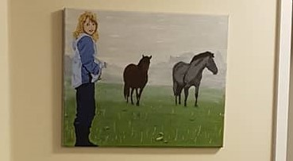

***

I was starting to feel good about my future as a painter. There was still a great deal of work to be done, and there always will, but I had succeeded in showing myself that if I continued to work hard at it there was every reason to believe there was enough raw talent for it to eventually work out well.

Even so, I decided it was time to get away from realism for a while. Portraits and landscapes painted realistically are quite exacting and exhausting, especially at my basic level of experience. I had learned a lot, even from the simple little paintings for the kids, in terms of brush strokes; how to move paint around; and working on steadiness of hand, to name just a few things. But there was a more fundamental reason to lay realism aside for a while.

I realized that, strictly speaking, realist painting is just copying. There was no place for me to insert myself into it, no expression of thought or feeling, no catharsis. I knew I would go back to realism in the future, but now I needed to move on to something more abstract, impressionist, and/or expressionist.

I decided to start with a simple impressionist painting of moonlight shining on the water in Branch. It was the same scene, from the same vantage point, as “My Happy Place”, and I did my best to channel my favourite impressionist painters. I remembered reading somewhere that impressionists like Van Gogh didn’t paint the objects, per se – they painted the light on the objects. I made a valiant stab at it, using a good deal of luminescent pearl, and “First Impression(ism)” came to be:

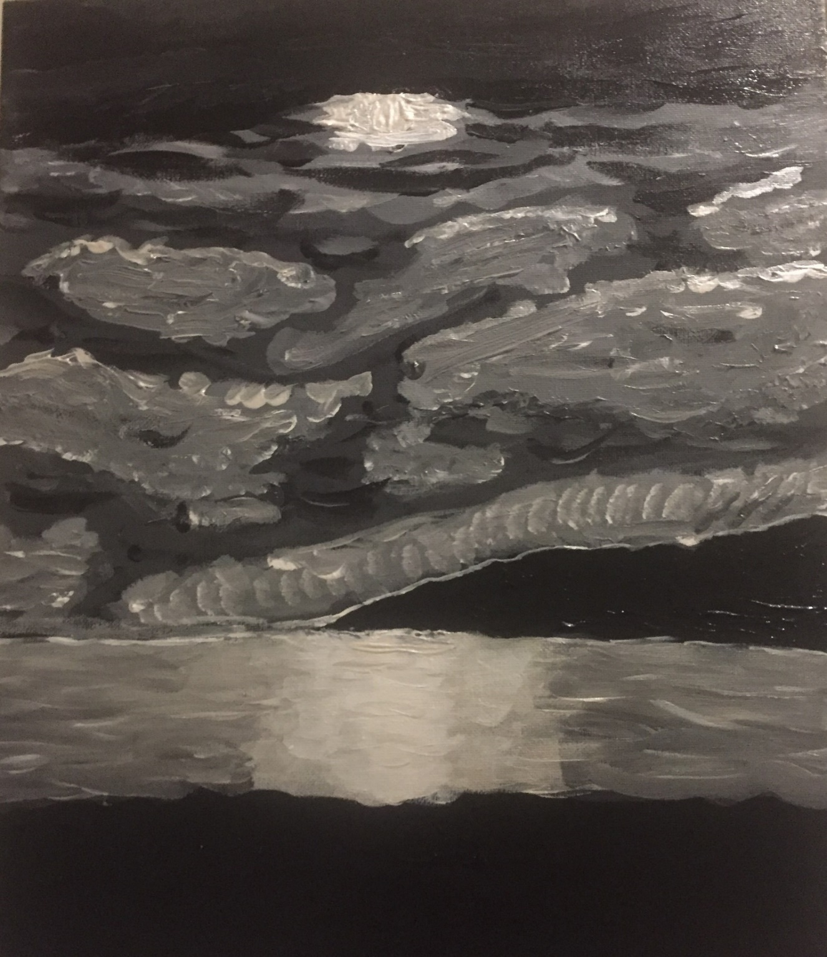

At first, I was underwhelmed with the result. It looked a bit too cartoonish to me at first glance; and I must confess that after all the precision necessary to paint realistically, I felt like I had just been lazy, like I had taken the easy way out doing such a piece. However, over time this changed significantly, and now it holds a special charm hanging in my studio, another reminder of a beginning made. And I must say that now I like it more each time I see it.

***

Next, I went for pure abstraction and boldness, pulling out all the stops. The activity in painting this piece was almost desperate, as if trying to exorcise something pent up inside me. As I did before, and would again more purposefully in the future, I instinctively drew on Nature for images and ideas. Branch is blessed with some of the most magnificent sunsets I have ever witnessed, so settling on doing something with a sunset was inevitable.

For some reason, my attention and imagination shifted from the singular to the plural, and I began to kick around the concept of “sunsets” instead. I asked myself: Could an abstract painting depict multiple sunsets? My imagination immediately answered: Why not? I started perusing images of sunsets, dozens upon dozens of them. After a while, I noticed that all sunsets have one thing in common – no matter what the variations, the sun’s light closest to the horizon is almost always white. In general, the colours gradually change from white to shades of yellow, to yellow, to shades of orange, to orange, to shades of red, to red, and on to a crimson brown. This became my template.

I decided to conceive of several sunsets across a canvas 36” high and 24” wide. First, with a pencil, I swept my hand capriciously across the white-gessoed canvas four times, more from top to bottom instead of side to side to further confound the appearance of real sunsets, creating four curved horizon lines. Then I went to work with paint, but used brushes only towards the end, to touch and tighten it up. Mostly, I simply squeezed the paint out of the tubes right onto the canvas, occasionally using a palate knife for edging and specific areas that required the paint to be literally pushed into place.

I remember feeling especially excited when I finished my first purely abstract piece, “Distorted Sunsets”…

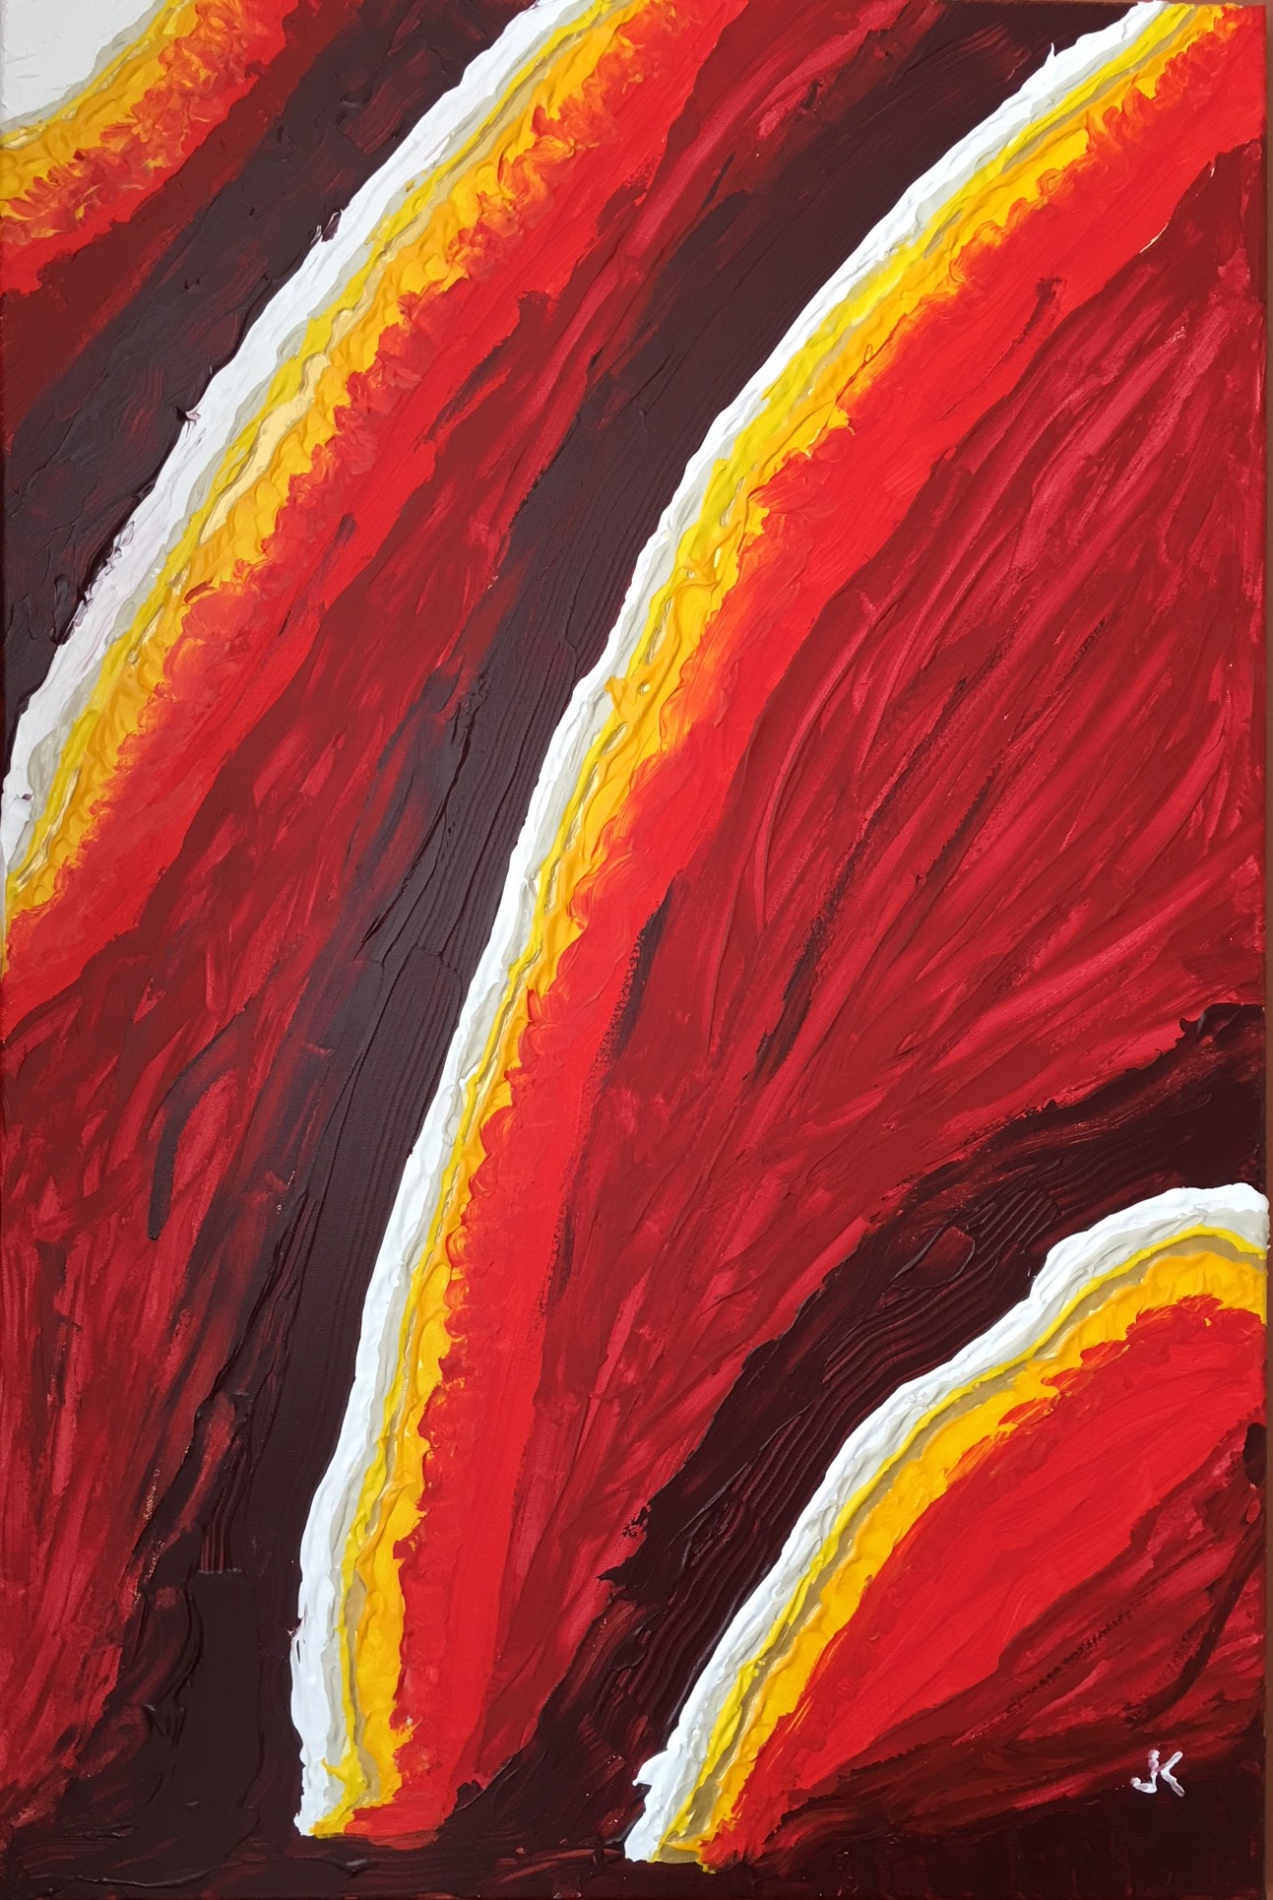
Here is a close-up section showing just how thickly the paint demanded to be applied in some places…

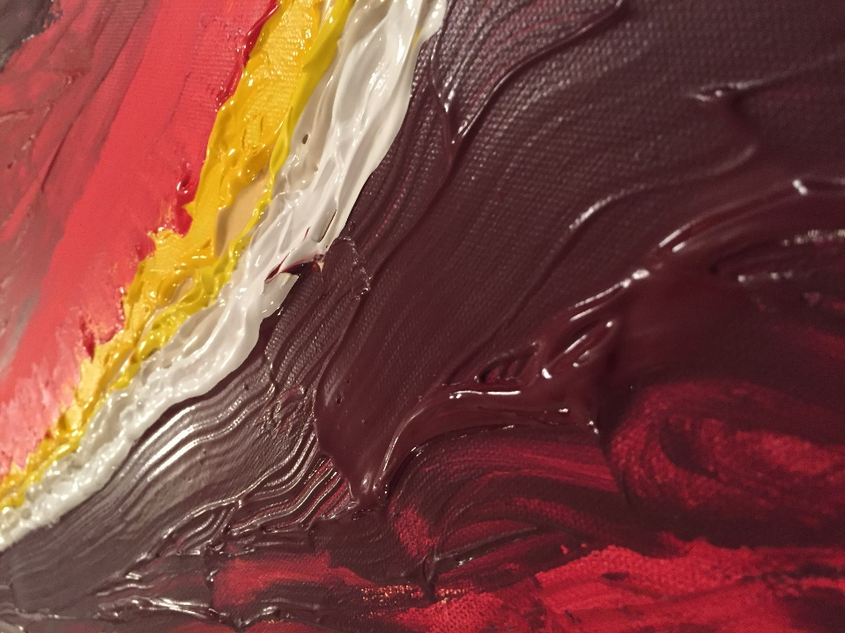

With “Distorted Sunsets”, I felt I had begun to create visual art that was good enough for sale. And, sure enough, after hanging in our living room for a year or so, it has brought several offers to purchase, but none high enough to make me part with it. But I am confident it will when the ABOTA store opens, if not before.

***

“Distorted Sunsets” and my next piece were both painted after completion of “M9 on the Flats”. About two weeks before Christmas, Tina’s older daughter, Pam (Aliyah and Adam’s mother), happened to mention in passing that she would love to have a nice big painting for her bedroom, with “lots of blues and grays…and with lightning…” The next day I headed for my studio in Branch, with only Pam’s words in my head as a guide, to paint another surprise Christmas present, this time for Tina’s other daughter. As with “Sunsets”, it would be quite bold and vivid Again, I was squeezing out paint and manipulating it with a palate knife, but this time it required a little more brush work. Then, on Christmas Eve, I presented Pam with “Lightning Blue”…

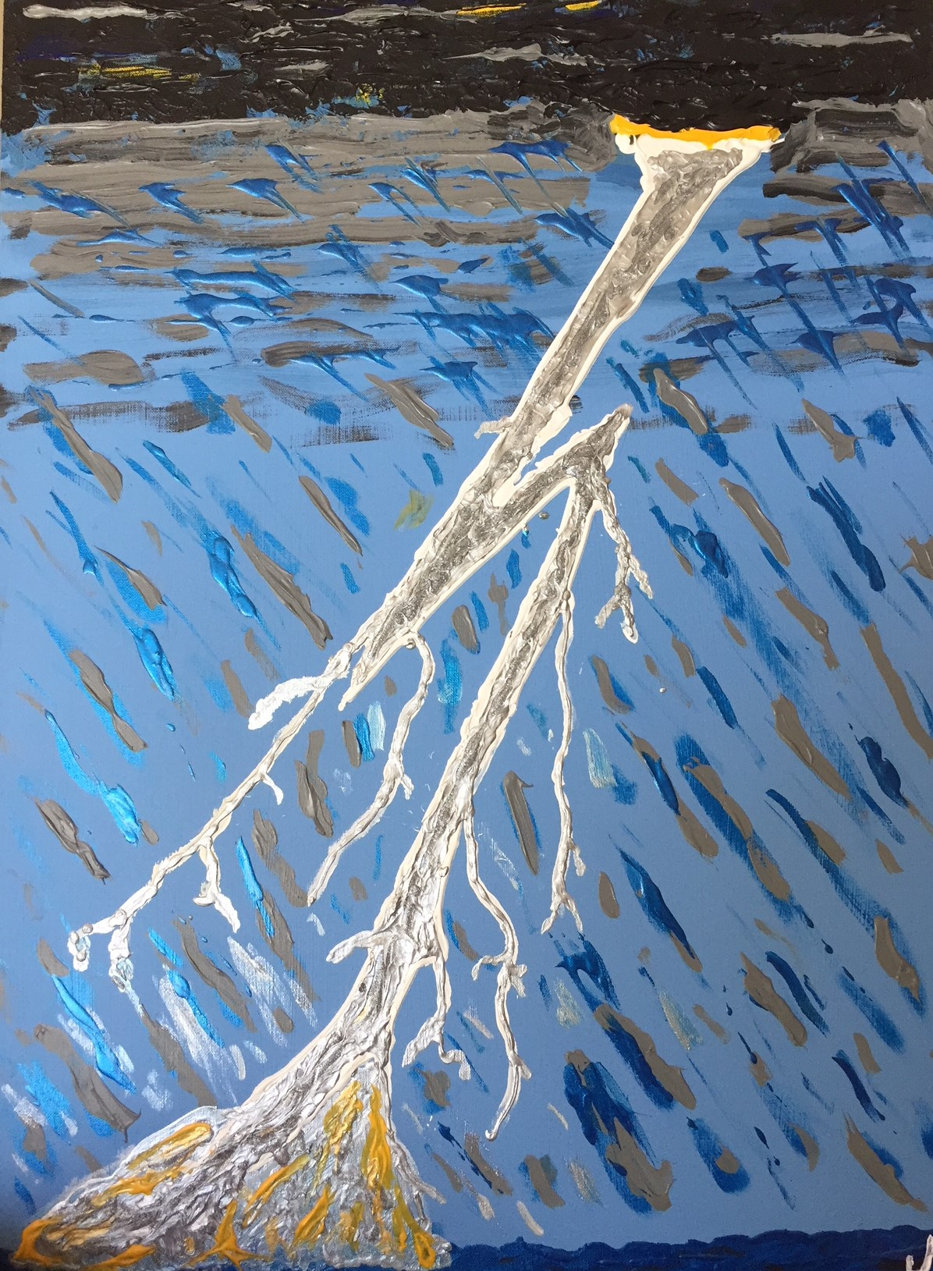

Pam loved it, and she hung it over her bed. But before long she wanted to be able to see it more often, and it now hangs over her desk at work.

***

The next acrylic painting came about because of my participation in an online art course offered by fellow Newfoundlander and artist Michelle Myrick-Olson of AMMO Artworks. Michelle’s “Soulful Art Making” was the first version of a course she was designing. She wanted to give it a test run, and I was fortunate enough to be one of her pupils. The course has since gone on to be a going concern, but my participation in the “beta” version of it really turned the corner on my progress as a painter.

The treatment and presentation of this piece here is especially detailed, and it is essentially an “anatomy of the creation of an abstract acrylic painting”. I do this for two reasons: 1) the story of its creation is fascinating; and 2) the process by which it was created is repeatable, yet will produce original, one-of-a-kind paintings that can be commissioned by members, and so will be available for purchase. “Random Symmetry” is the painting I did right after completing the course, grounded in the course instructions.

Here I present the painting’s development parallel to the progression of the course, as they mutually define each other. “Soulful Art Making” broke down the process of the creation of an art piece, in this case a painting, into five distinct steps. This was quite helpful because it showed me where one stage ended and the next began, whereas lines between the steps in my process thus far were quite blurred. More importantly, it made each successive stage more meaningful and purposeful, which made them much more effective. The course helped me in many ways, including ways I did not know existed before the course, and ways I know I have yet to discover and learn from.

Step One involved looking at two pictures Michelle had posted for her students online, and we were asked to free associate by putting down the words that first came to mind when looking at them. Then, with these words, we were to go online and look at Google images that come up when each word was entered into the Google search engine. My first engagement of the pics Michelle posted, which were shots of two different architectural facades that both had a mass of intricate, detailed tree branches/roots carved into it, elicited words like “tree” and “peacock”, indicating my initially literal interpretation of what I was looking at. This soon gave way to words like “network”, which immediately told me there was something much deeper being evoked in me.

Then I realized that, when confronted with an example of Nature’s works of art, or even an artist’s rendering of one of them, such as in a painting or photograph like each one of these, I become fascinated by something very specific that I have never really identified. Selfishly, I saw the Soulful Art Making course as an opportunity to chase it down.

The photographs originally posted, and the other pictures I was led to find subsequently, spoke loudly and clearly to me of two fundamental forces at work in Nature: randomness and symmetry. Throughout Nature we find freeform randomness in the distribution of her elements, but most often these elements are wondrously symmetrical in and of themselves. Moreover, there is a lively, almost palpable interplay between randomness and symmetry in all her works, and an underlying tension as well. This beautiful, fundamental struggle embedded in the grandness of the whole and the complexity of the details, as in the appearance of a great oak tree or a proud bird’s plumage, is a natural paradox that intensely fascinates me as a thinker and inspires me as an artist. It was easy for me to take “random symmetry” as my jumping off point to the next step.

In Step Two, we were instructed to select two or three of the words, and the images that became associated with them, and to start sketching freely. I considered many examples of randomness in Nature that might be helpful in my sketching, finally settling on rain, and on the randomness of falling rain in particular. I thought: What if it rained black ink and I had a white canvas laid out flat on the ground? The drops would be of varying size and, depending on the strength and duration of the precipitation, would produce a random distribution of black dots of all sizes on my white canvas.

Therefore, the first phase of my sketching began with me playing Nature, if you will, placing different sized dots “randomly” on the canvas. As with Nature’s randomness, the different drops would not always be spaced similarly in relation to each other, nor equidistant from one another (i.e. sometimes two or three will be closer together in places, and further apart in others). The varying sizes of drops were the beginning of the levels of depth in the work, as larger dots would appear closer, smaller dots more distant.

Here is the first stage of “Random Symmetry”:
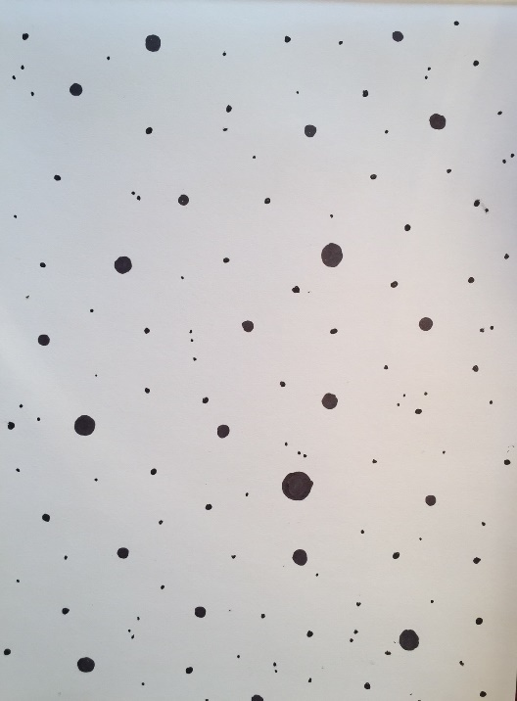

Now I needed to introduce the symmetry. Considering examples of natural symmetry (e.g. fractals, snowflakes), I decided that stars offered the best options. They could be built upon the dots and governed by their size, providing a variety of ways to enhance the levels of depth in the sketch. The second and third phases of the sketch built on this by using each layer of depth to have different kinds of stars, each increasingly smaller.

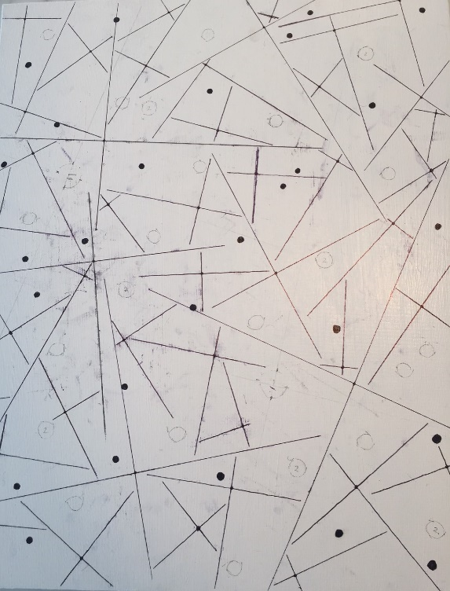

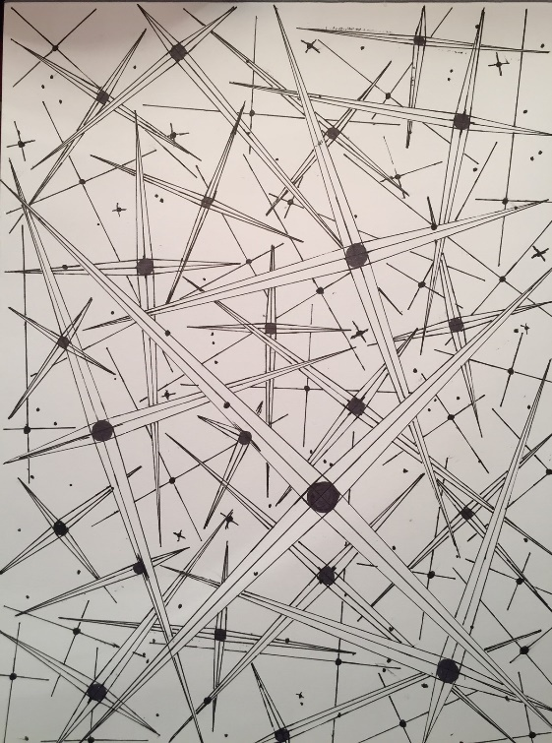

Already I could visualize the sketch re-created on a canvas, and colour in the paints bringing it all to life.

Step Three was consideration of the composition of the piece to be created, and materials needed to create it. It also involved transferal of the sketch and its potential, conceptually and physically, from paper to canvas, then running with the second step to its logical conclusion. I work in acrylic, so to begin with I needed a 16” X 20” white-gessoed canvas, and the same sketching materials (fine-tipped pencil and a straight edge). I made photocopies of the sketch with just the dots to experiment and determine the exact nature of each layer of stars; from minute dots (some of which could be applied at the end) to long thin cross-stars, and on to increasing sizes of the bigger coloured stars. I began to transfer the sketch from paper to a white-gessoed canvas.

I experimented with colour for the different layers of depth. I felt that the first layer (appearing farthest way) on the white canvas should be black and intricate, and subsequent layers would move progressively from black to increasingly lighter colours. The black and white sketch had so much balance and was so pleasing to the eye, I decided to use just primary colours of acrylic paint (blue-to-red-to-yellow) reminiscent of the 20th century Dutch artist Piet Mondrian (the red, yellow and blue lights in the Molson Canadian bar sign that we can’t take our eyes off also comes to mind). I would use a black ink pen and a black felt tip Sharpie for the basic black background and the first of four layers of depth.

So much was learned from sketching: the best order in which to apply the materials for the various elements in the composition; ways to improve on the use of the different elements (e.g. stars on the same level don’t intersect). I also experimented with colour using photocopies of the final sketch on paper and realized the execution of the fourth step (creation of the piece) was almost completely determined ahead of time, and I had but to enjoy the creative journey. In almost a year of painting, producing more than a dozen paintings, this was the first work that was conceived and created with nothing but a single guiding principle – random symmetry – and it was a principle that set all the “rules” for the materials, composition and application. With this painting, I knew what I was driving for and exactly when I was finished (another first).

I started by applying size and depth to the black and white “star skeltons” built on the biggest dots (each a simple x/y axis), which would be the nearest yellow stars; then did the same with the next smallest dots for the next farthest red stars.

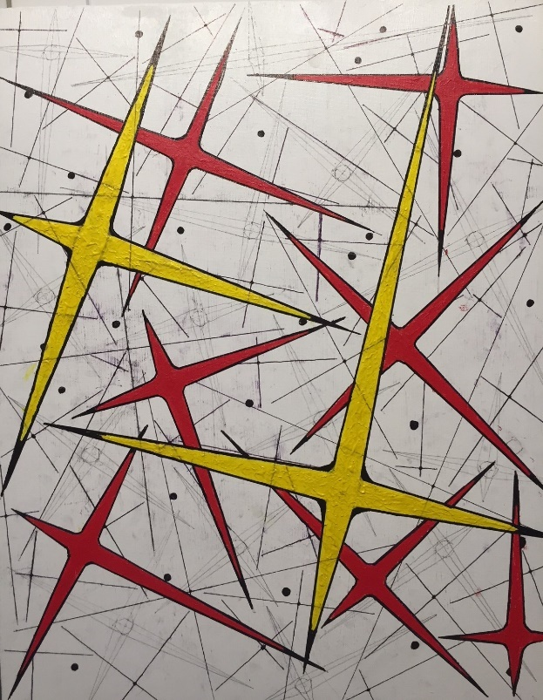

Then the next farthest blue stars were added, enhancing each thin black and white star/axis (farthest away of all except for the black dots and stars in the background).

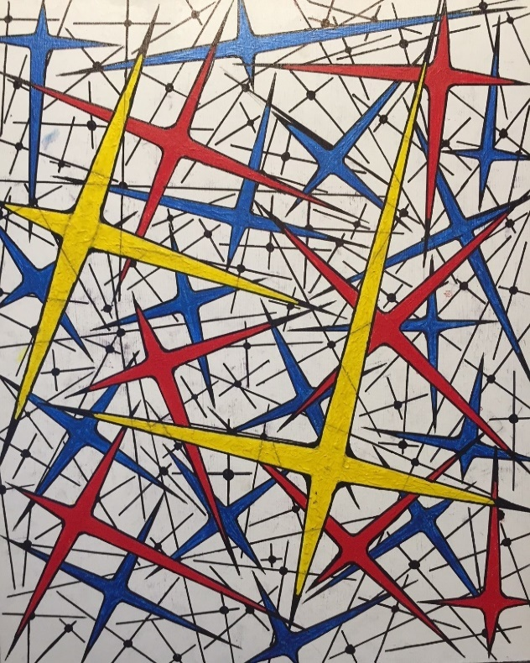

At this point, I could see that there was enough room to make some of the more prominent black and white stars thicker, and just a bit smaller than the blue stars.

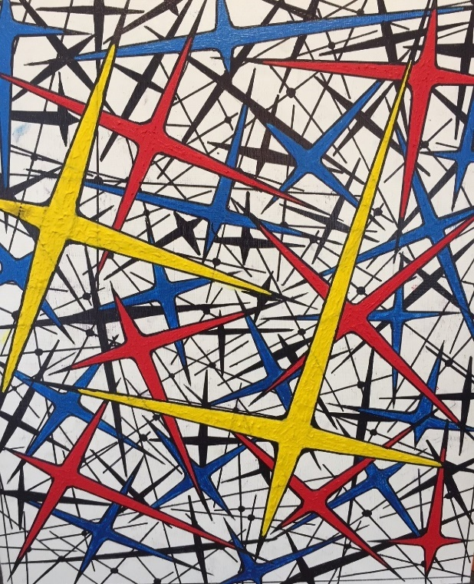

Cleaning up all smudges, adding random dots for some even more distant stars and touching up where necessary, “Random Symmetry” was completed.

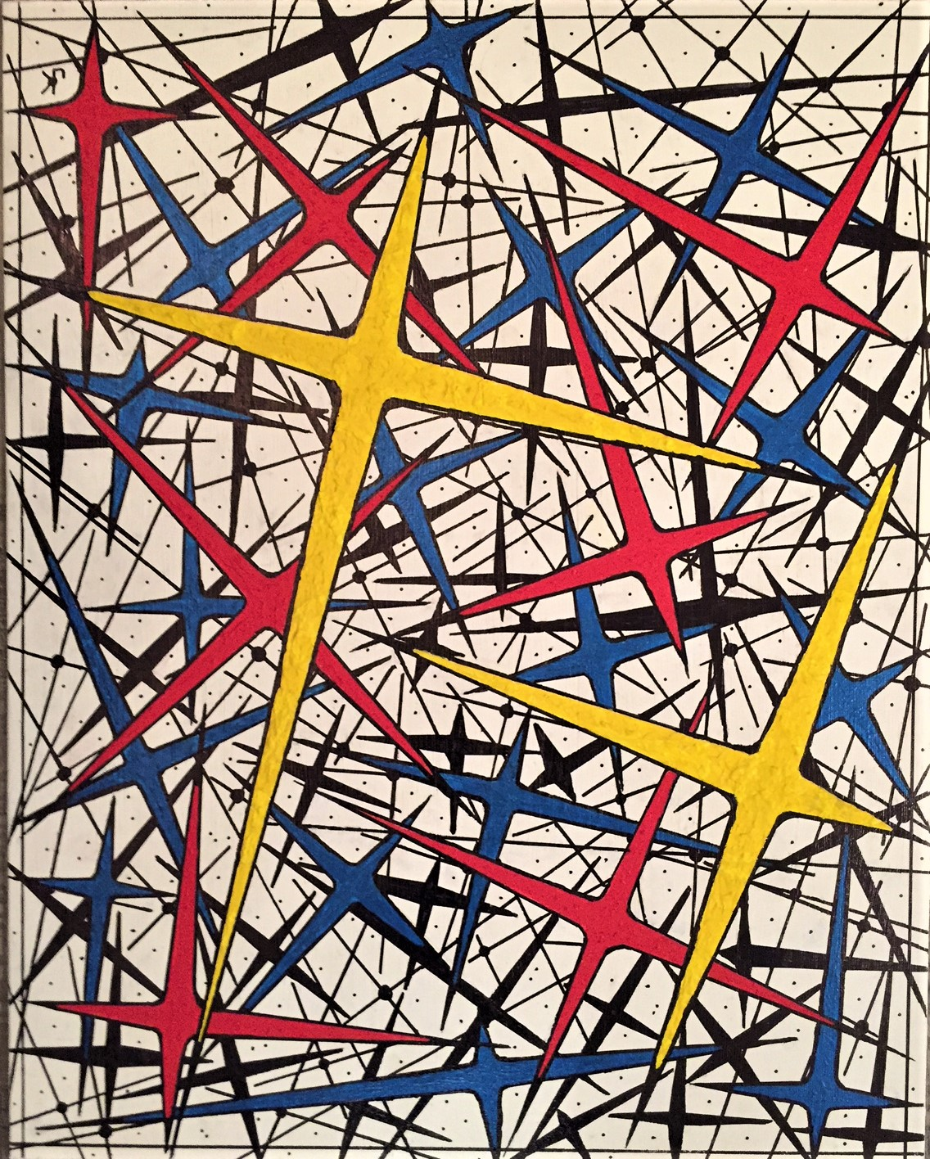

Two important additional aspects came to mind during the creation of this piece, and both were incorporated into the final work: 1) thick black borders around the edges of all coloured stars helped with defining stars and contrasting colours; and 2) heavy stippling of the paint on the yellow stars, less so on the red stars, and even less so on the blue, helped bring home the levels of depth in the piece.

Step Five of the course was about reflecting on the process and sharing our pieces and thoughts with the other members of the class. Soulful Art Making taught me a lot about what I haven’t been doing well with my painting to date; but, just as importantly, it had a great deal to say about what I’ve been doing right, why, and how to refer to it! As a thinker, my experience with “randomness versus and yet in harmony with symmetry” was the most fascinating part. There is a tug of war going on between them, whether in Nature or in art; they are almost parallel. In the creating, there was a delicate, nuanced admixture of them at times; a bold contrast between them at other times. And sometimes I could almost feel the pulling and pushing between them, their special dynamic very much alive in the working and in the work, symbiotic, and mirrored in the artist’s full use of both freedom and precision.

But more than this, I felt I was gaining an insight on the nature of reality to some extent, and along the way all the well-worn dichotomies in philosophy took turns appearing out of the work, then receding back into it, only to be replaced by the next: smoothness and edge; inside and out; subtly and boldness; light and dark… The list is endless, and it teaches us that Nature generates and displays endless models of life in life itself, and even in the complexity of human life.

Soulful Art Making and the creation of “Random Symmetry” taught me a great deal about making art, about how I make art, but also about Nature and reality. I am grateful for what I saw there, and for getting a chance to know what I hadn’t yet realized. It has become a key factor in my creativity, and I don’t ever expect that to change. I never felt more a painter, and never surer of what I was doing and what I was capable of as a painter.

Second, the response from viewers of “Random Symmetry” to date has been universally and enthusiastically positive, almost effusive at times. Many commented on the illusion of depth, and how they felt drawn into it thereby. And, in all cases, there was a sense of wonder elicited, a look of almost hypnotic pleasure, facial expressions indicating that the piece was at once appealing and fascinating – pleasing to the eye, yet strangely interesting to the soul. No doubt, I get the same look on my face when I view, or rather, gaze upon it.
Furthermore, it very much lends itself to commissions, and I see a series coming out of it. Each commissioned opus of “Random Symmetry” will have the exact same scheme, but the positions of the dots, axes and stars would change, giving each one a quality that delivers the same strong appeal as the original.

* * *

One of the most adorable parts of our little dog, Schatz, is his mouth area. So adorable, in fact, I had to paint a close-up of it. I particularly like the texture in this one. It is titled: “His Chops”…

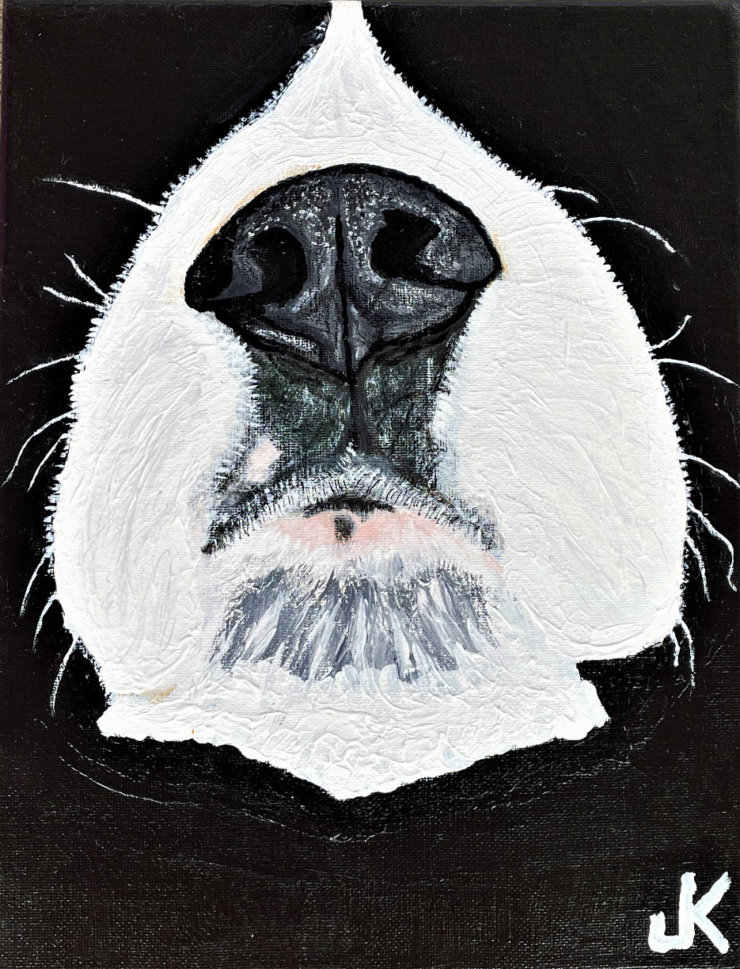
* * *

We moved to Miramichi, New Brunswick, and rented a house in 2020, then we purchased and renovated a house to make our new home on the banks of the Miramichi River. One of the most fortuitous finds on the new property was a beautiful birch tree, standing proudly and smack dab in the middle of the acre between the house and the river. I have come to affectionately dub this lovely tree “The Centerpiece”.
My first piece of artwork with this tree as the subject was a pencil sketch (see the Visual Art Archive Sect. 3: Sketches and Drawings). For my first painting of the tree, I decided to idealize it. Today it hangs in our kitchen, and I call it “Birch at Night”…


  

