The Visual Arts Archive

* * *

Section 1: Acrylic Painting (Part Two)

For my next acrylic painting project, I wanted to do a series of colour studies, something I had been looking forward to doing for some time. The way some colours seem to thrive beside another colour has always captivated me, especially when they compliment each other. This one, with basic orange and primary yellow on a field of Hooker's green, I call "Autumn Revelry"...
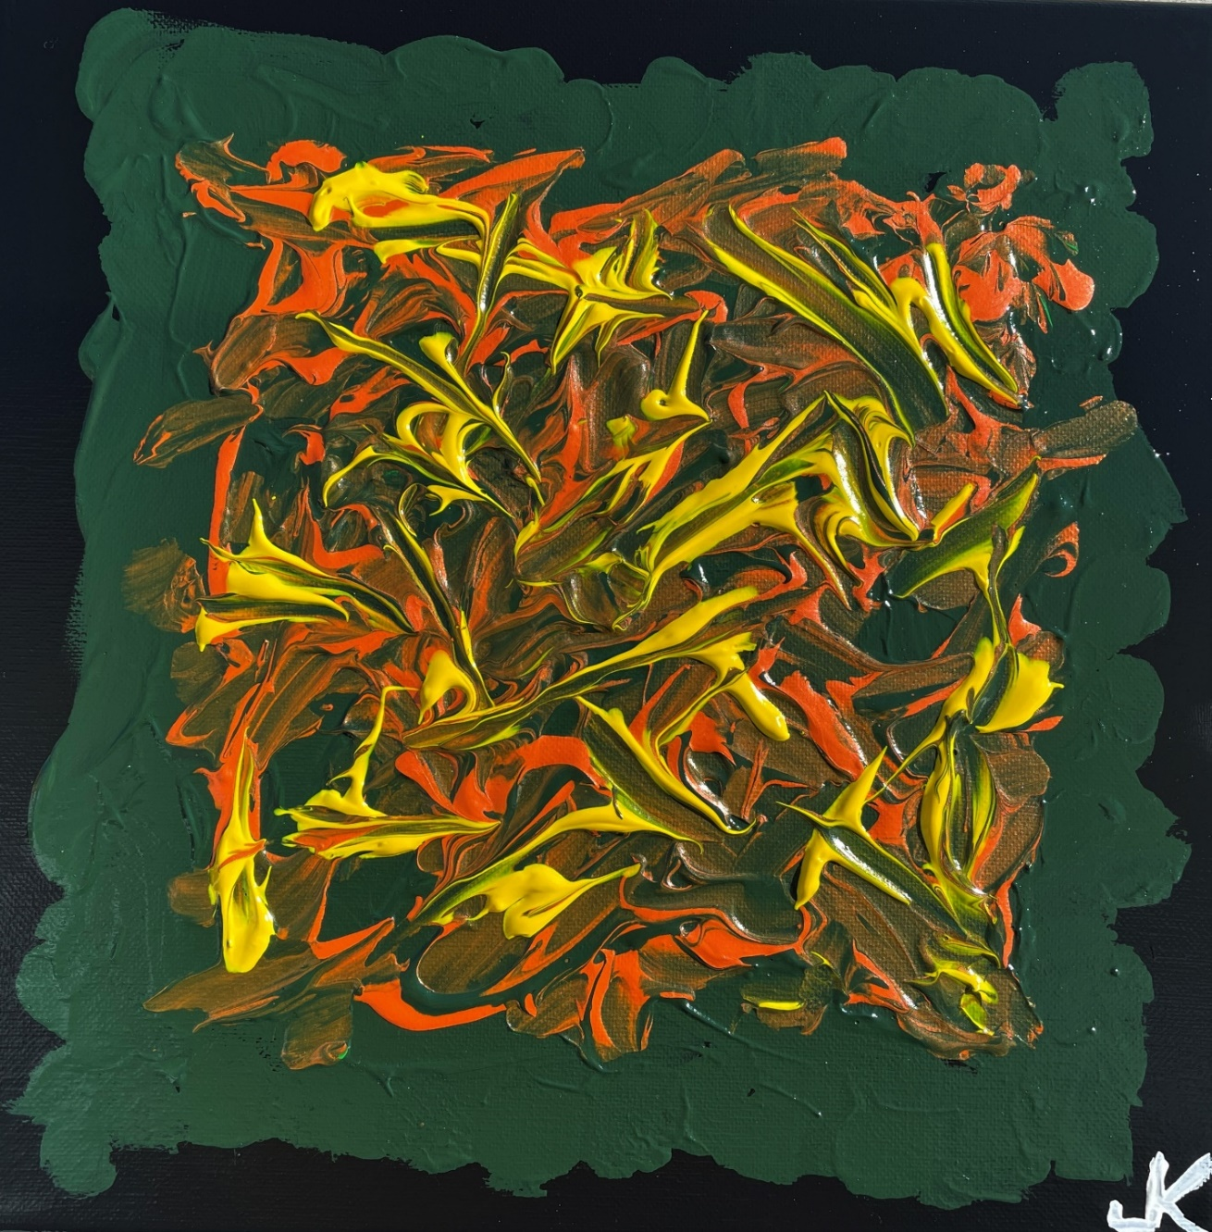
Next, I turned to my memories of Middle Cove Beach, a popular summer location just outside St. John’s in Newfoundland. The beach in Branch, St. Mary's Bay, has every kind of rock you can imagine; every colour and shape; sedimentary, metamorphic, and igneous. The rocks on Middle Cove Beach, however, are all typical beach rocks, and predominantly just three colours - gray, red-pink, and various shades of white. I call this study "Middle Cove Mash." Nature is the original canvas…

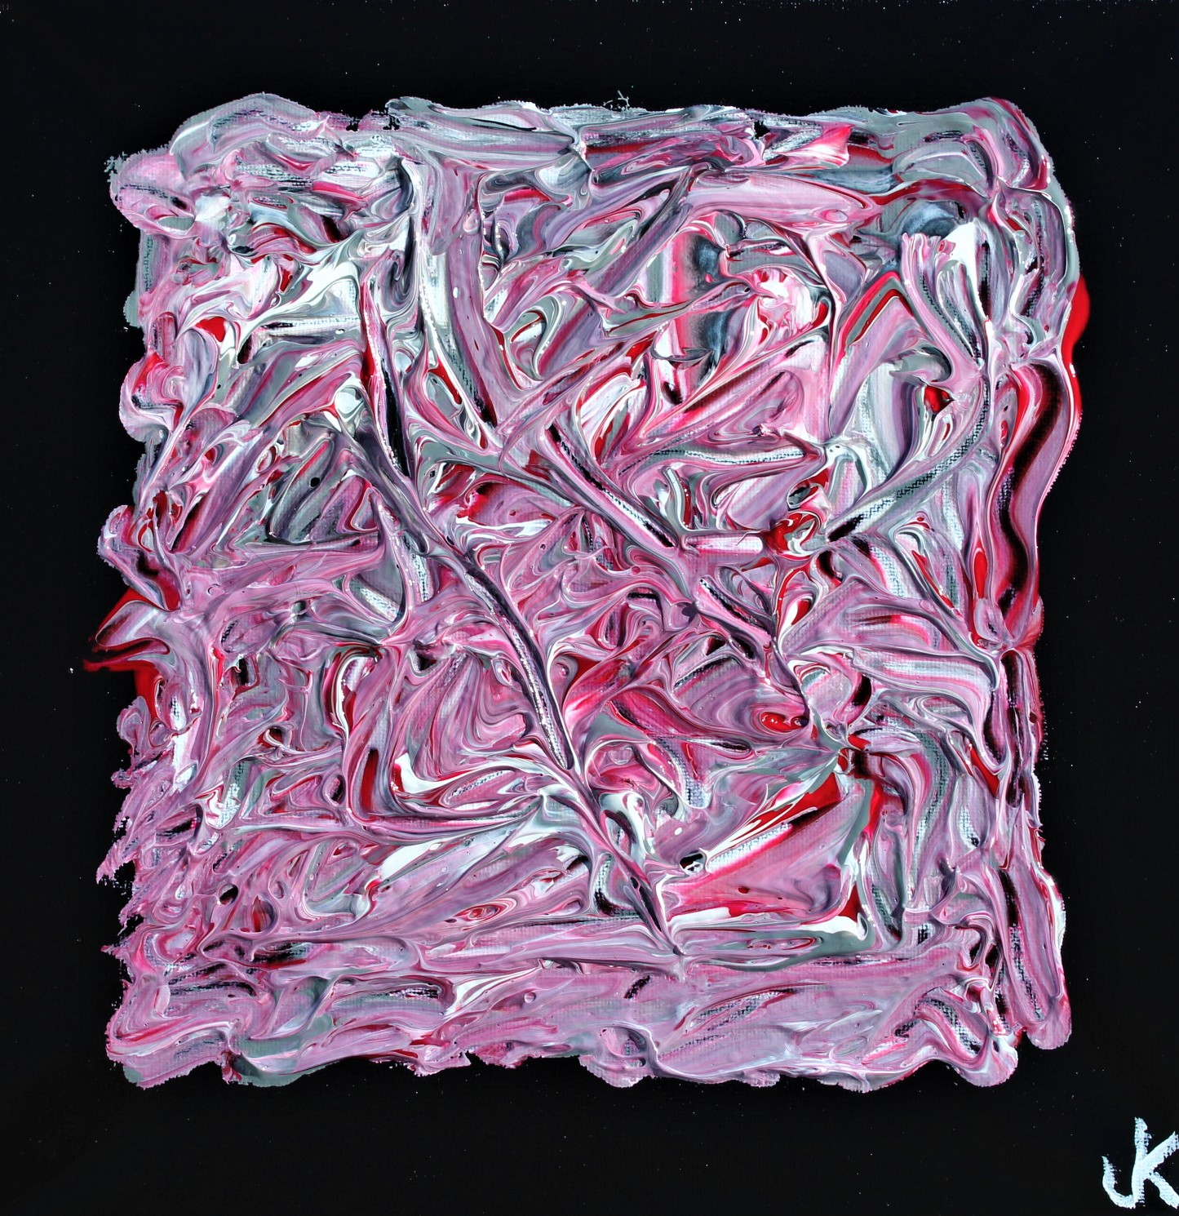

At the time I was doing this series of colour studies, the Russian invasion of Ukraine was happening. This one is a colour study of brilliant blue and cadmium yellow, with a little titanium white. Blue and yellow is a popular combination with a lot of sports teams, like the L.A. Rams. But the maelstrom of colours involved in this piece, coupled with what was happening in eastern Europe, meant that this piece could only be titled: "Ukraine Chaos, 2022"…

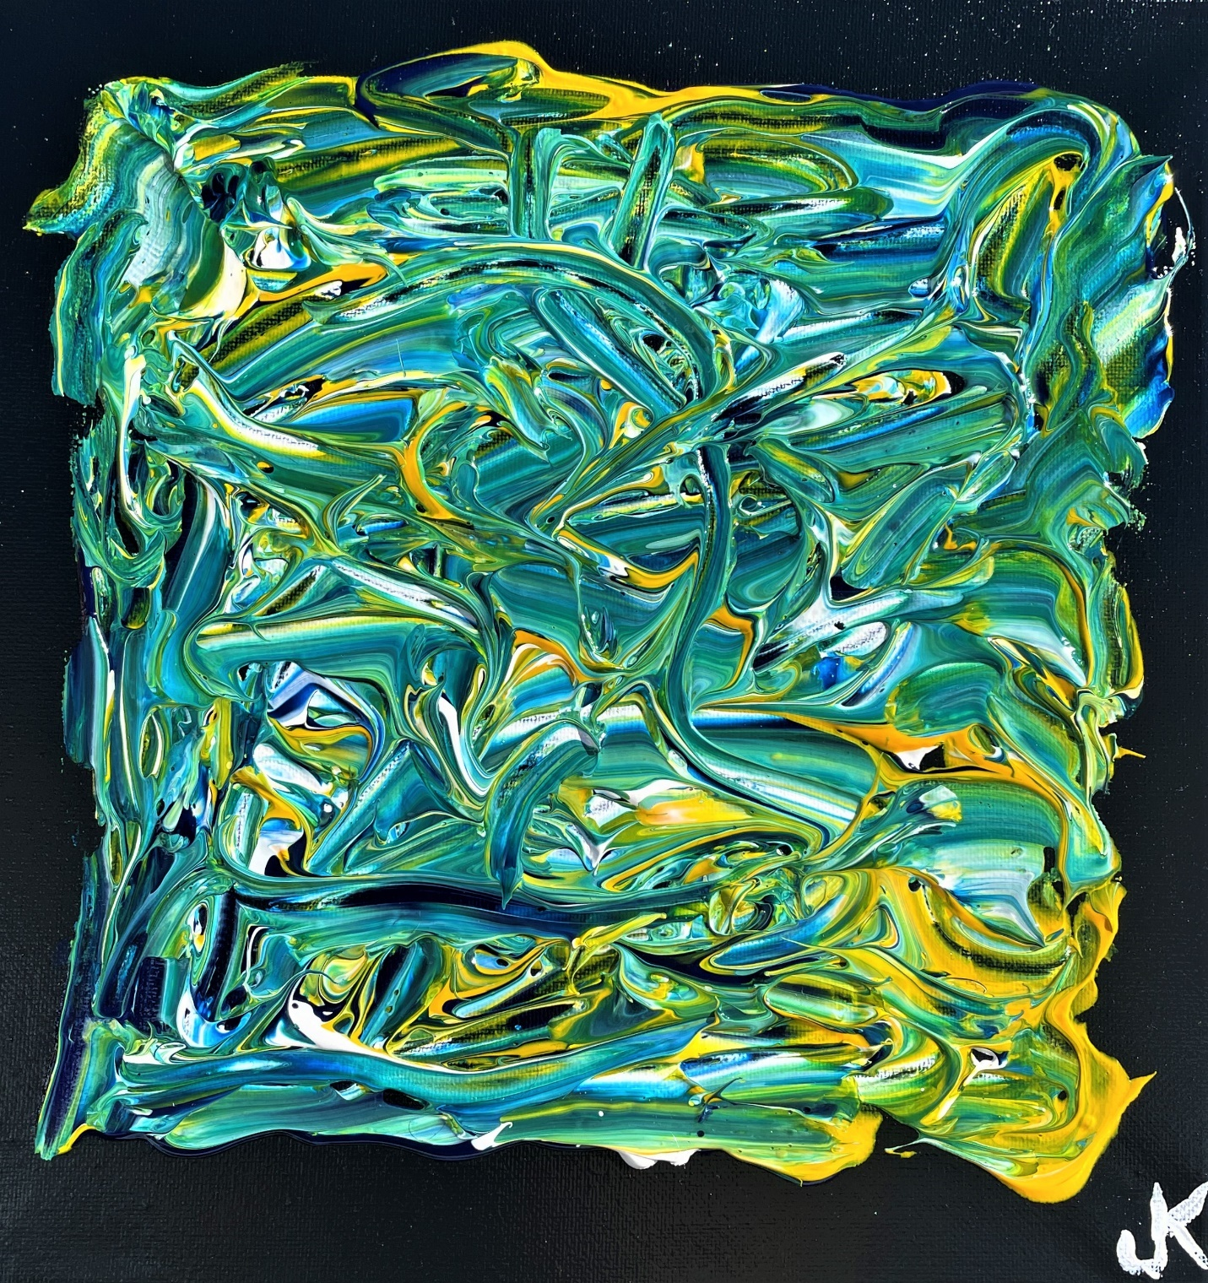
For the final colour combination in the series, I turned to the primary colours – red, yellow, and blue. You may remember the Molson Canadian sign of lights that used to be in a lot of night clubs, in which the three primary colours would gradually come in one colour at a time until the sign was complete, then it would go blank and start over again. It always seemed to draw your attention, pleasing as these colours are to the human eye; and if you happened to look at it when it was only part way through the sequence, it was hard to look away before it was finished.
I decided to do an arrangement of one large piece accompanied by two smaller pieces. I used cadmium red, cadmium yellow, and phthalo blue. I call it "Dance of the Primaries", and as with the other colour studies, the originals hang in our home…

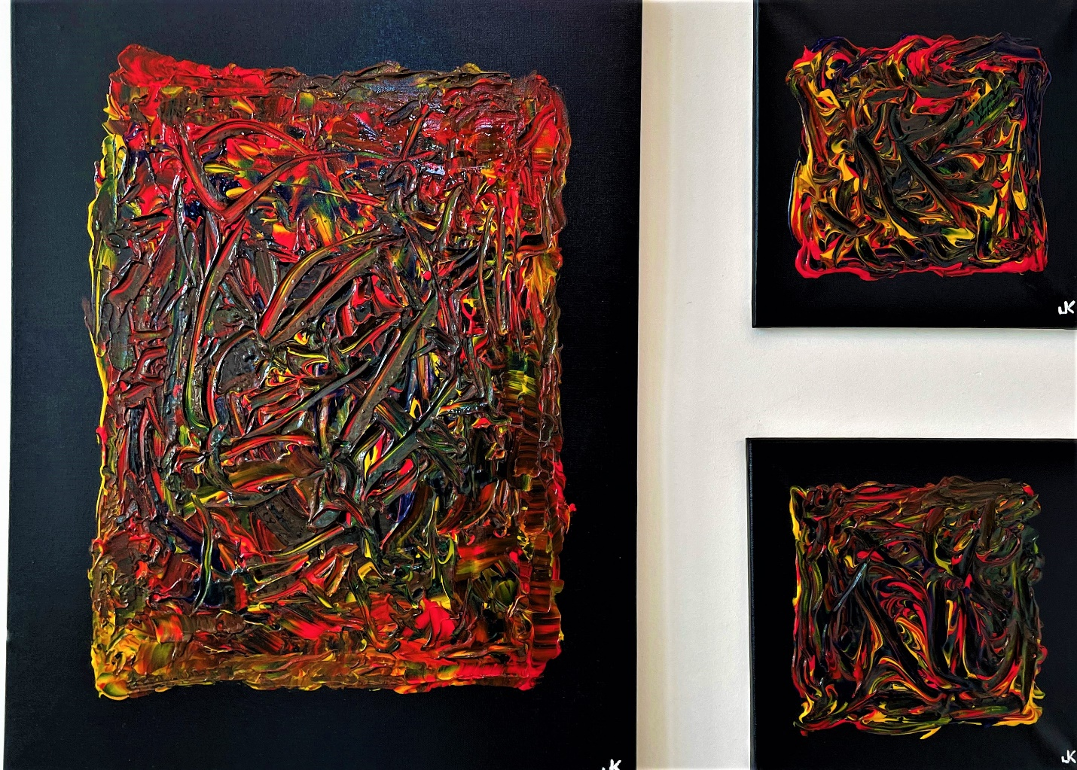

And here they are separately…

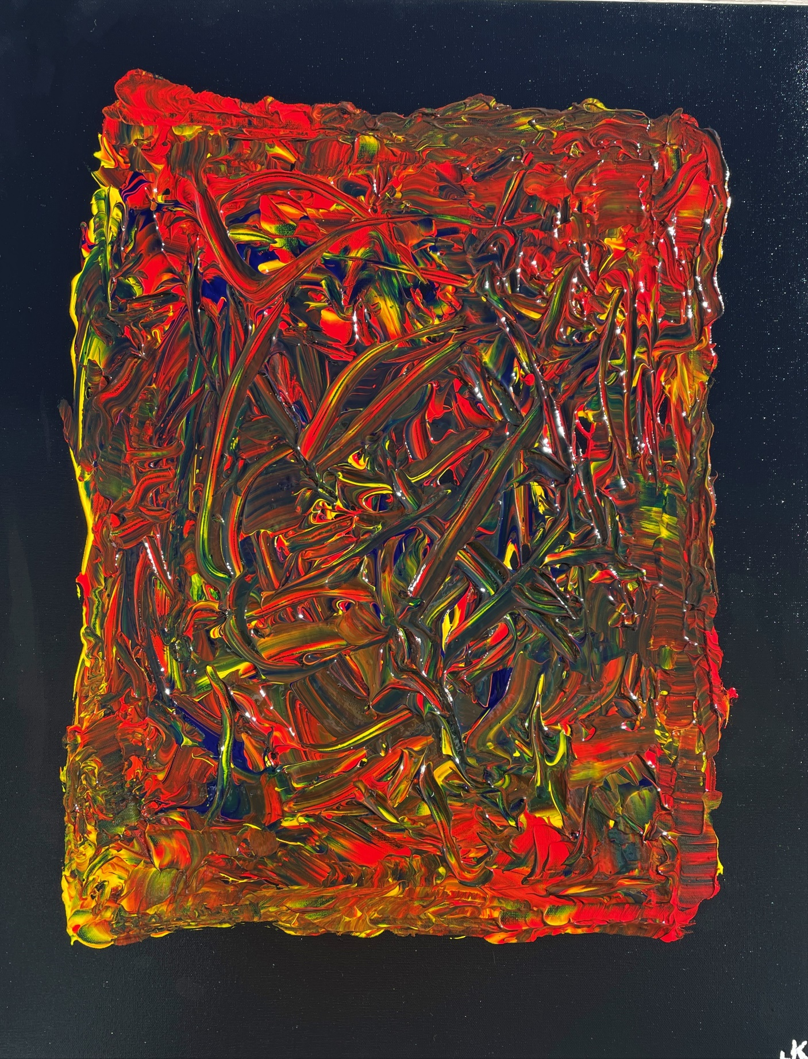

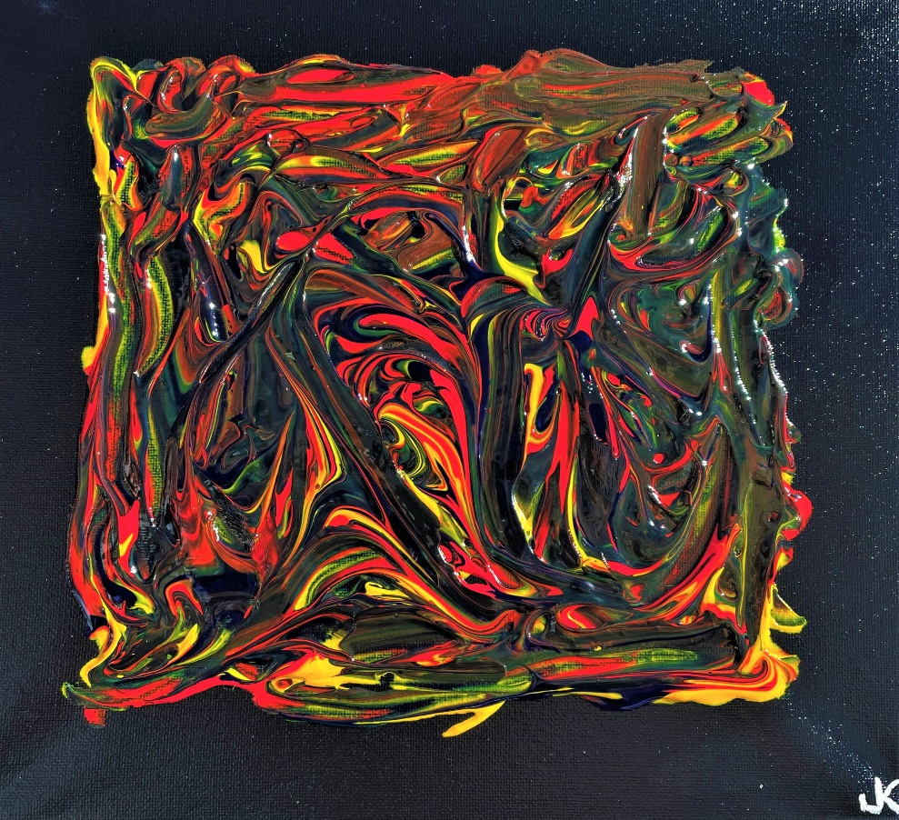
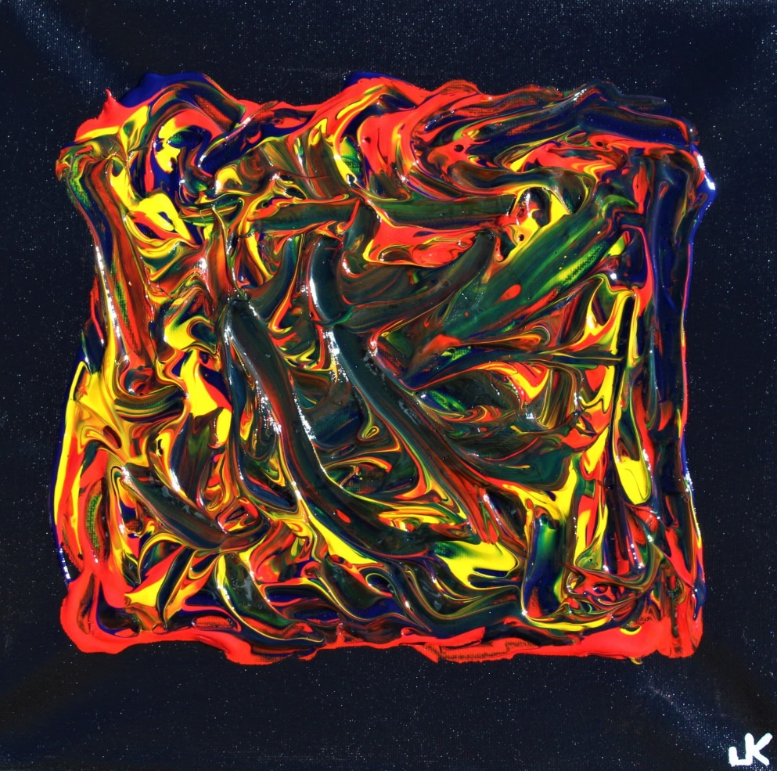
* * *

As seen in the previous section, one of my colour studies in early 2022 was dedicated to the Ukrainian people, devastated by the Russian attacks and occupation. However, with the numbers of Ukrainians killed and wounded increasing by the day, with civilian residential areas and even hospitals being targeted, like many artists, I felt I needed to creatively express my outrage with Russia and my solidarity with the Ukrainian people in a more substantial way. I wanted to depict how Russian forces at the behest of their dictator, Vladimir Putin, were inflicting themselves on Ukraine and the impact on its people. The result: “Invasion, 2022”.



  

